**ASSIGNMENT 2 FRONT SHEET**

|  |  |  |  |
| --- | --- | --- | --- |
| **Qualification** | **BTEC Level 5 HND Diploma in Computing** | | |
| **Unit number and title** | 10: Website Design & Development | | |
| **Submission date** |  | **Date Received 1st submission** |  |
| **Re-submission Date** |  | **Date Received 2nd submission** |  |
| **Student Name** | VO NHUT HUY | **Student ID** | GCC18169 |
| **Class** | GCC0801 | **Assessor name** | NGUYEN HUNG DUNG |
| **Student declaration**  I certify that the assignment submission is entirely my own work and I fully understand the consequences of plagiarism. I understand that making a false declaration is a form of malpractice. | | | |
|  |  | **Student’s signature** | Nhut Huy |

**Grading grid**

|  |  |  |  |  |  |  |
| --- | --- | --- | --- | --- | --- | --- |
| P5 | P6 | P7 | M4 | M5 | D2 | D3 |
|  |  |  |  |  |  |  |

|  |  |  |
| --- | --- | --- |
| **❒ Summative Feedback: ❒ Resubmission Feedback:** | | |
| **Grade:** | **Assessor Signature:** | **Date:** |
| **Signature & Date:** | | |

**ASSIGNMENT 2 BRIEF**

|  |  |  |  |
| --- | --- | --- | --- |
| **Qualification** | **BTEC Level 5 HND Diploma in Computing** | | |
| **Unit number** | 10: Website Design & Development | | |
| **Assignment title** | Web Services Presentation and Guidebook | | |
| **Academic Year** | 2018 – 2019 | | |
| **Unit Tutor** |  | | |
| **Issue date** |  | **Submission date** |  |
| **IV name and date** |  | | |

|  |
| --- |
| **Submission Format:** |
| *Format:*   1. A report document including some sections  * Section 1: A review of appreciate web design principles, standards and guidelines. * Section 2: Design document for online shopping website. * Section 3: Implementation of website design. * Section 4: Test plan and test evaluation.  1. A compressed file that encapsulates all source code and particular necessary resources including files of images, style sheets, java script and other files to support to install multipage website such as sql script and installation guide.   *Submission* Students are compulsory to submit the assignment in due date and in a way requested by the Tutors. The form of submission will be a soft copy posted on <http://cms.greenwich.edu.vn/>  *Note:* The Assignment *must* be your own work, and not copied by or from another student or from  books etc. If you use ideas, quotes or data (such as diagrams) from books, journals or other sources, you must reference your sources, using the Harvard style. Make sure that you know how to reference properly, and that understand the guidelines on plagiarism. *If you do not, you definitely get failed* |
| **Unit Learning Outcomes:** |
| **LO3** Utilise website technologies, tools and techniques with good design principles to create a multipage website.  **LO4** Create and use a Test Plan to review the performance and design of a multipage website. |
| **Assignment Brief and Guidance:** |
| You work as a full-stack web team leader for a leading creative web solutions and marketing company. Your team is about to have a big contract to develop an online shopping mall.  In order to finish your work effectively you need to review all appropriate principles, standards and guidelines for website designing and development, evaluate all technical challenges to produce a good design document for the online shopping website with wireframes, functional illustrations and a full set of client and user requirements. Then, you lead your team to utilize web design and development technologies, tools and techniques to implement your web design to develop the online shopping website. To get good result, you always ask your team for following your design document by comparison between created multipage website with your design document and evaluation.  As your role, to ensure that the multipage website for online shopping developed by your team is a high quality product, you also need to ask your team members to follow quality assurance process and implement it during your design and development stages by creating a suitable test plan. The test phase should be seriously implemented by reviewing and analysing all test results to evaluate applied quality assurance process and point out suggestions of improvements for online shopping website |

|  |  |  |  |
| --- | --- | --- | --- |
| Learning Outcomes and Assessment Criteria | | | |
| Pass | | Merit | Distinction |
| **LO3** Utilise website technologies, tools and techniques with good design principles to create a multipage website | | | **D2** Critically evaluate the design and development process against your design document and analyse any technical challenges. |
| **P5** Create a design document for a branded, multipage website supported with medium fidelity wireframes and a full set of client and user requirements.  **P6** Use your design document with appropriate principles, standards and guidelines to produce a branded, multipage website supported with realistic content. | | **M4** Compare and contrast the multipage website created to the design document. |
| **LO4** Create and use a Test Plan to review the performance and design of a multipage website | | | **D3** Critically evaluate the results of your Test Plan and include a review of the overall success of your multipage website; use this evaluation to explain any areas of success and provide justified  recommendations for areas that require improvement. |
| **P7** Create a suitable Test Plan identifying key performance areas and use it to review the functionality and performance of your website. User Experience (UX) and User Interface (UI). | **M5** Evaluate the Quality Assurance (QA) process and review how it was implemented during your design and development stages. | |

Contents

**P5. Create a design document for a branded, multipage website supported with medium fidelity wireframes and a full set of client and user requirements.** 7

I. Create design document 7

II. Architecture of the Application 8

III. Data Flow Diagram 8

IV. Use case diagram 9

V. Database diagram 9

VI. Site map 9

VII. Wire frames and specific explanation 10

**P6. Use your design document with appropriate principles, standards and guidelines to produce a branded, multipage website supported with realistic content.** 11

1. Registration 13

2. Login to the registered account 14

3. Update Profile 17

4. Product category management function 19

5. Log out function 28

**P7. Create a suitable test plan identifying key performance areas and use it to review the functionality and performance of your website. User Experience (UX) and User Interface (UI). 29**

**P5. Create a design document for a branded, multipage website supported with medium fidelity wireframes and a full set of client and user requirements.**

1. Create design document
2. Client and user requirement analysis

* Project Specification
* VIC.com is an online store for various types of T-shirts, hoodies, and the shop's branded teddy bears. They have a collection of bags. Now they want to revamp their website with all the products listed on the website. Consumers should find it easy to view various products and decide upon purchasing the right product to meet their requirements.
* A website needs to be designed to display various T-Shirt, Hoodie available with the store. Details of locations, feedback must be included.
* The website is to be developed for the Windows Platform using HTML5, CSS, JavaScript and PHP. The site should work well in all leading browsers including Chrome, IE, Firefox etc
* Client: VIC Shop
* Input provide by the Client:
* Information about T-Shirt: Product Name, Price, Quantity, Image
* Information about T-Shirt category: category name, Description.
* Information of customer: Username, password, fullname, email, telephone, gender, date of Birth.
* Output from the system
* List T-Shirt Category.
* List all T-Shirt and T-Shirt detail.
* Process involved in the system
* Processing customer’s registration.
* Processing customer’s login.
* Adding, updating, deleting T-Shirt category.
* Adding, updating, deleteing T-Shirt.
* Scope of the Work
* Website design for online shopping with many integrated pages.
* Customers are Registered members of the site and log in to buy products
* For administrators, perform the following functions:
* Add, edit and delete products.
* Add, edit and delete product categorie.
* Customer Acceptance Criteria

|  |  |
| --- | --- |
| No. | Customer Acceptance Criteria |
| 1. | The website interface must display the Logo of the shop (VIC SHOP) with functions that the admin and the customer can manipulate. |
| 2. | The Home Page should be created making use of sections with a suitable logo, the header section can be added which will show images of various t-Shirt. |
| 3. | Customers can register for membership of the store then log on to the website. |
| 4. | Use the product in the database |
| 5. | Login security (using special characters can not login to the account) |
| 6. | Description and Pricing of products such as T-Shirt, Hoodie, and BearBrick should be added along with the images. |
| 7. | Has the function to change personal information |
| 8. | Administrators can perform the functions   * Add, edit and delete products * Add, edit and delete product catalogs |
| 9. | Administrators can perform the following functions: Add, edit  and delete products |

1. Architecture of the Application

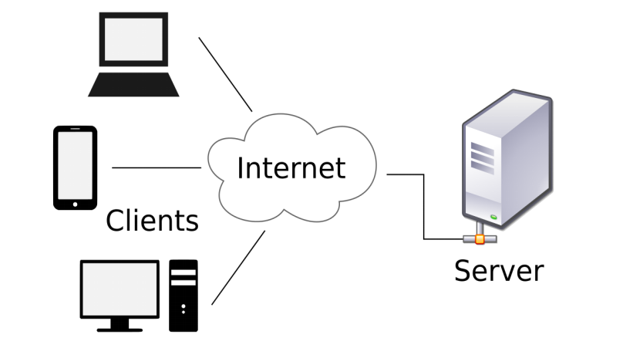

1. Data Flow Diagram

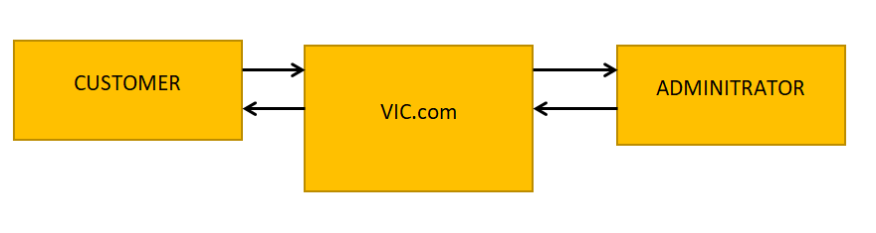

LEVEL 0 DFD

1. Use case diagram

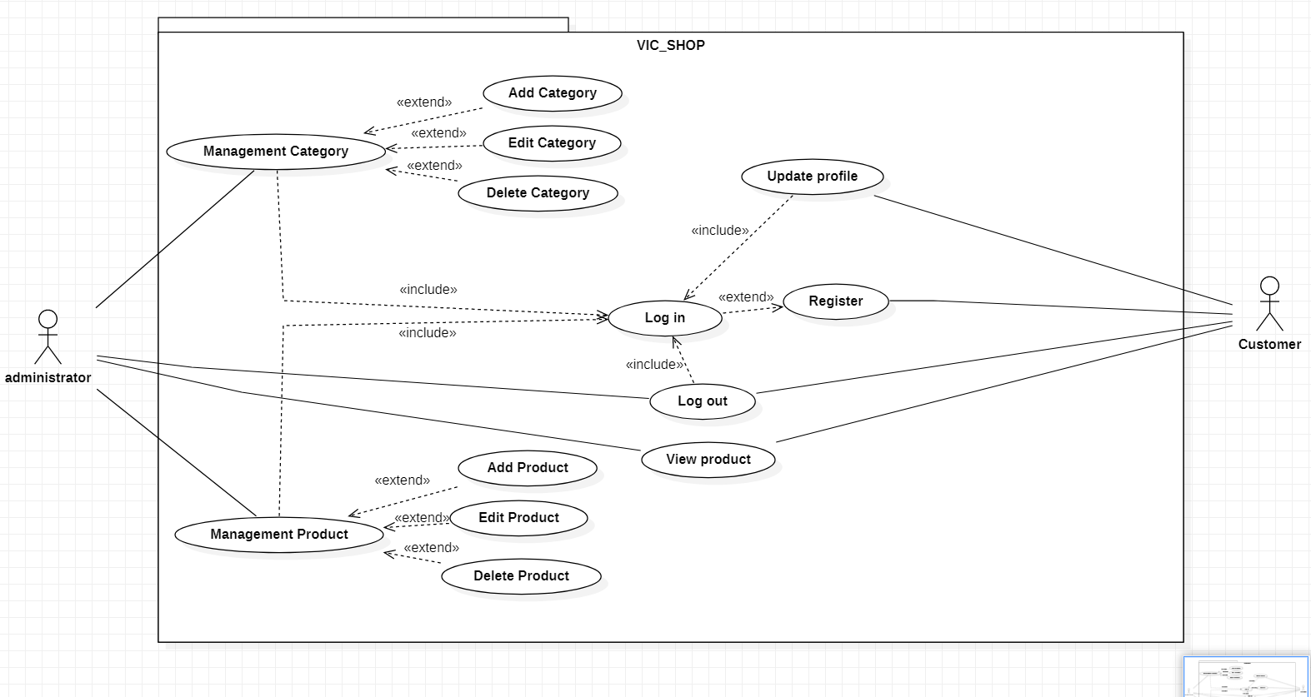

1. Database diagram

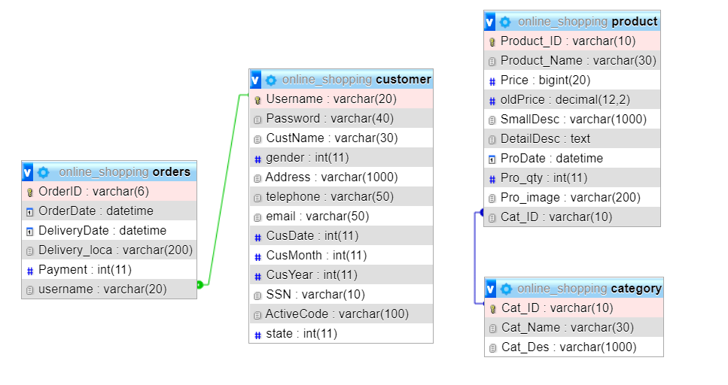

1. Site map

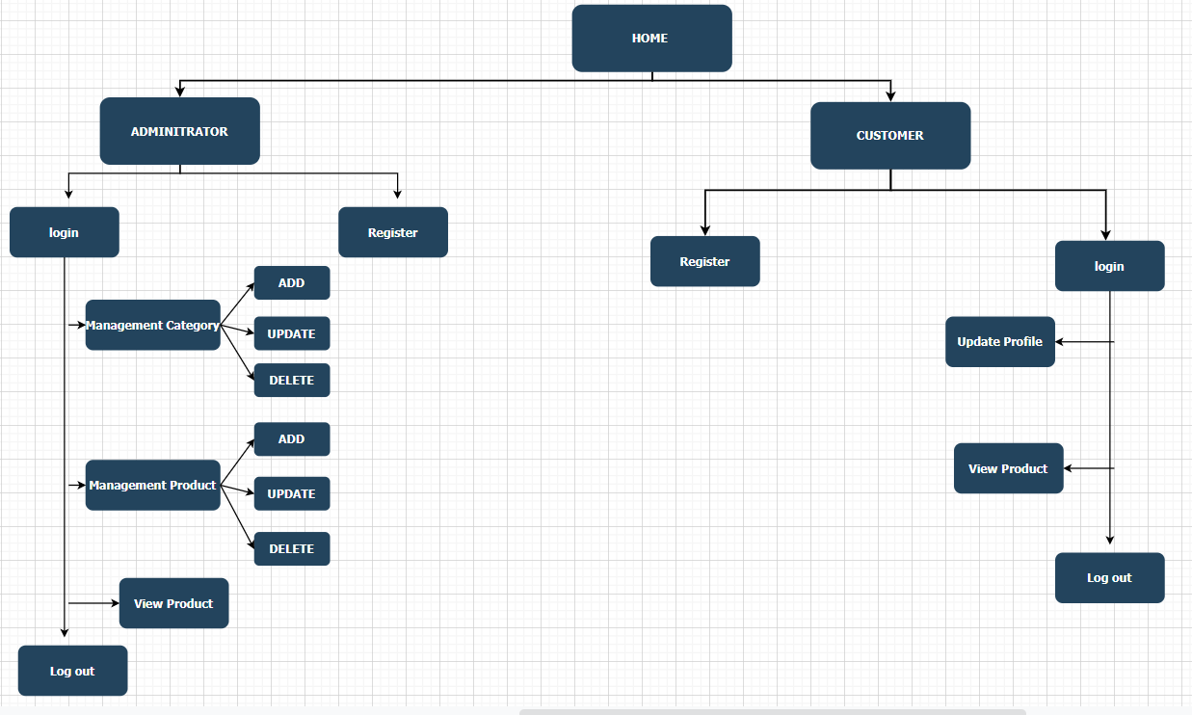

1. Wire frames and specific explanation

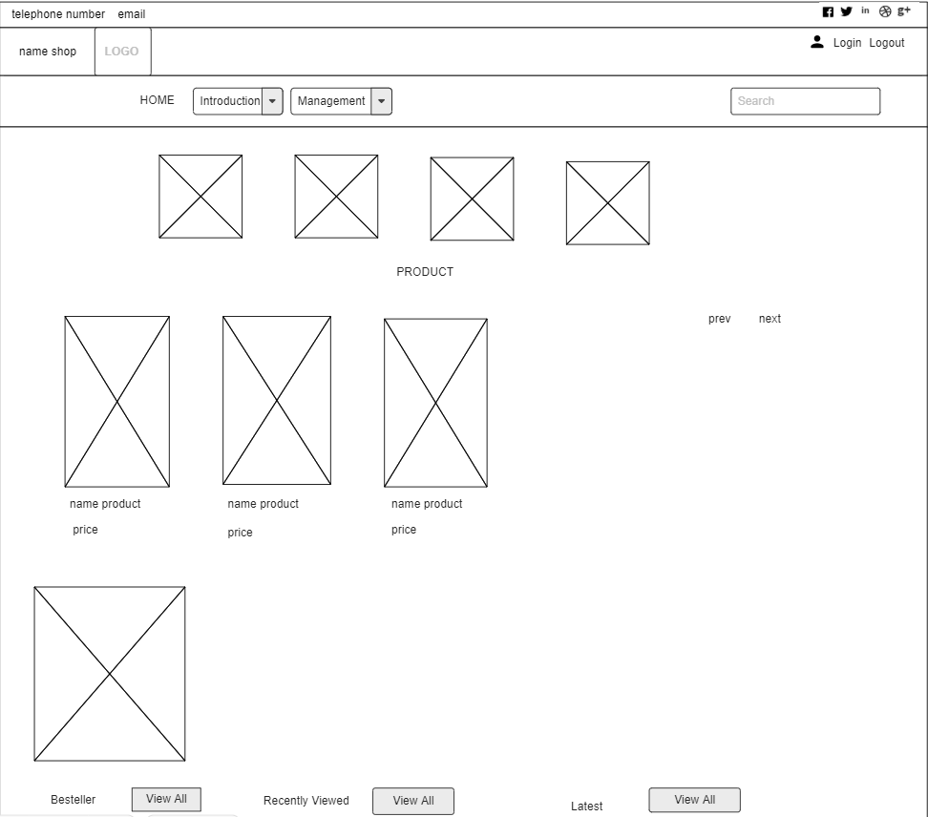

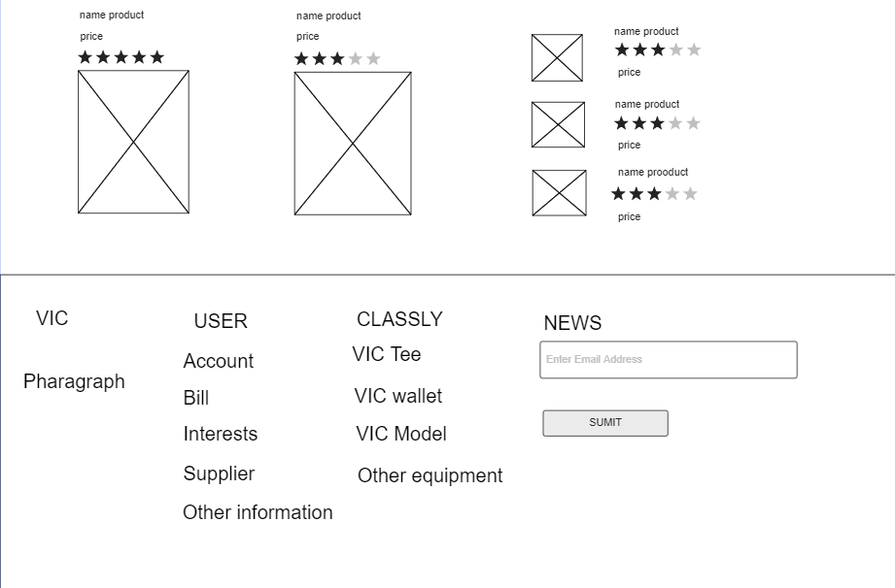

* Based on the request of VIC.com, they need a website with a navigation section that is designed to be user-friendly and easy to use. The featured image rotates when the user clicks on the "next" button, which displays the different product categories of the store such as T-Shirt, Hoodie, BearBrick ... When customers visit the website, they will see the name and product price below picture. From there, customers can see the type of news and promotional products. When the customer sees it and wants to buy it, they can refer to the above services including ship, exchange return every 30 days, payment security, new product. The bottom of the page will display the introduction of VIC shop and many social contacts.

**P6. Use your design document with appropriate principles, standards and guidelines to produce a branded, multipage website supported with realistic content.**

* The interface of the website is as follows:

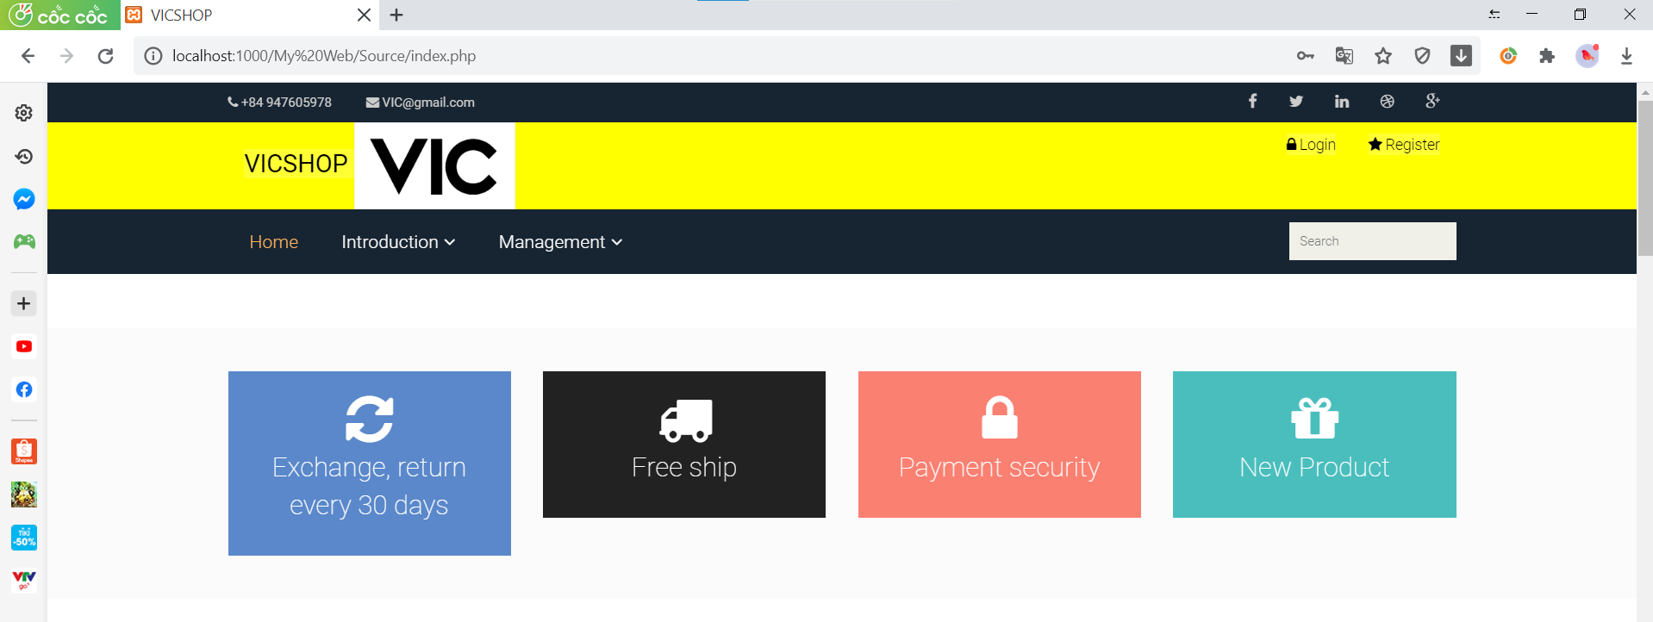

Figure 1: Interface on the top of the website

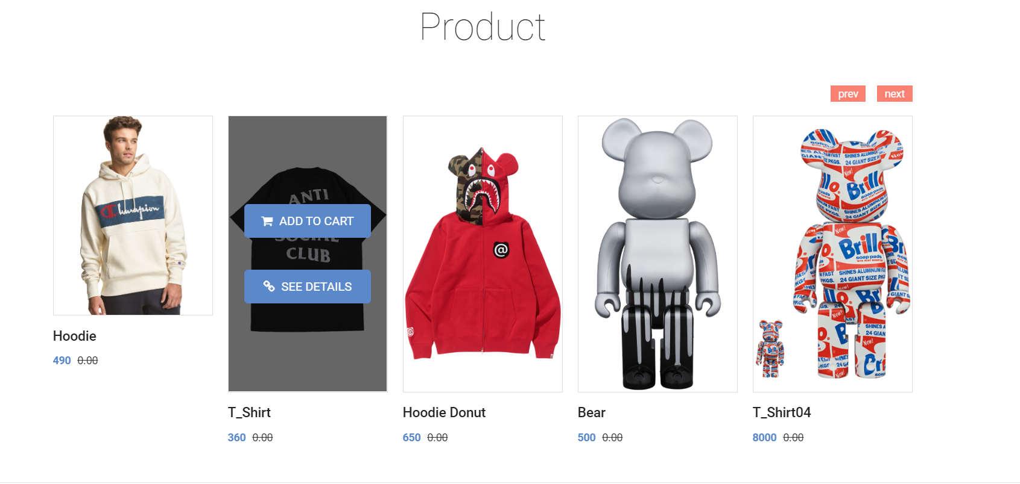Figure 2.1: Layout of the middle part of the website

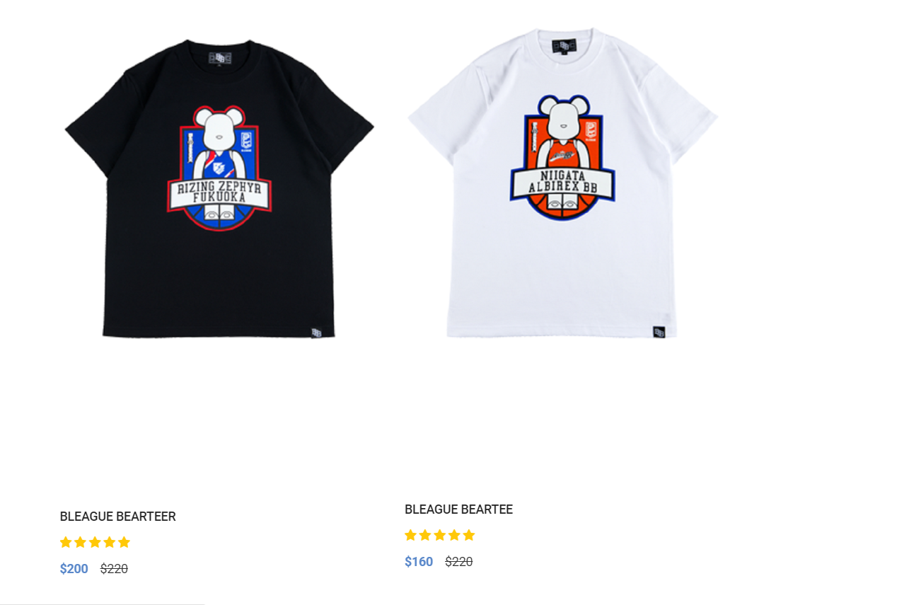

Figure 2.2: Layout of the middle part of the website

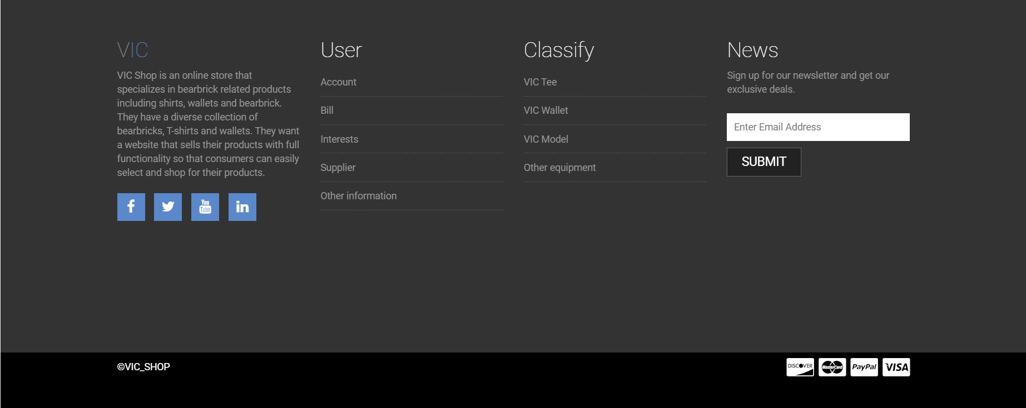

Figure 3: Layout of the bottom part of the website

* The functions of the website

1. Registration

Figure 4: Register button

* When the user clicks "Register" on the website, the website will display the page where the user's information is required below.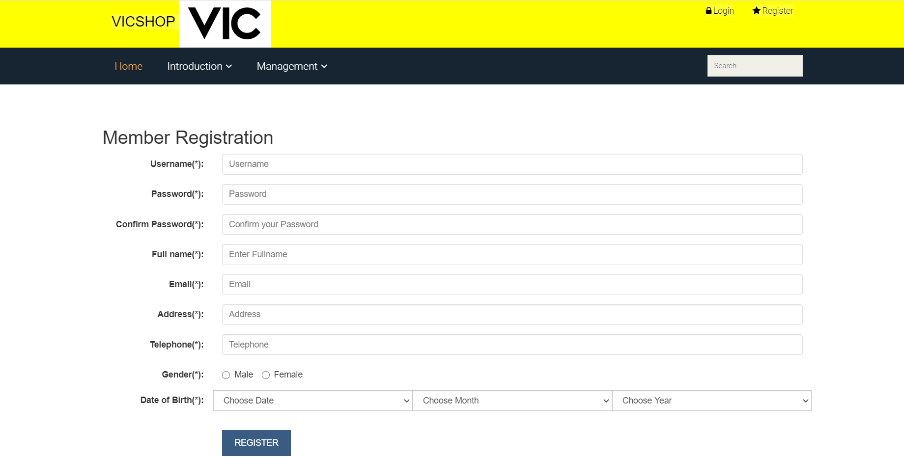

Figure 5: Page member registration

* The user needs to enter all the correct information that the "Member Registration" page offers.
* Example:
* If a user signs up for a password that is too simple or less than 5 characters, the website will not allow users to register and notify the user "Password must be greater than 5 chars" and force users to register a password and import more than 5 characters.

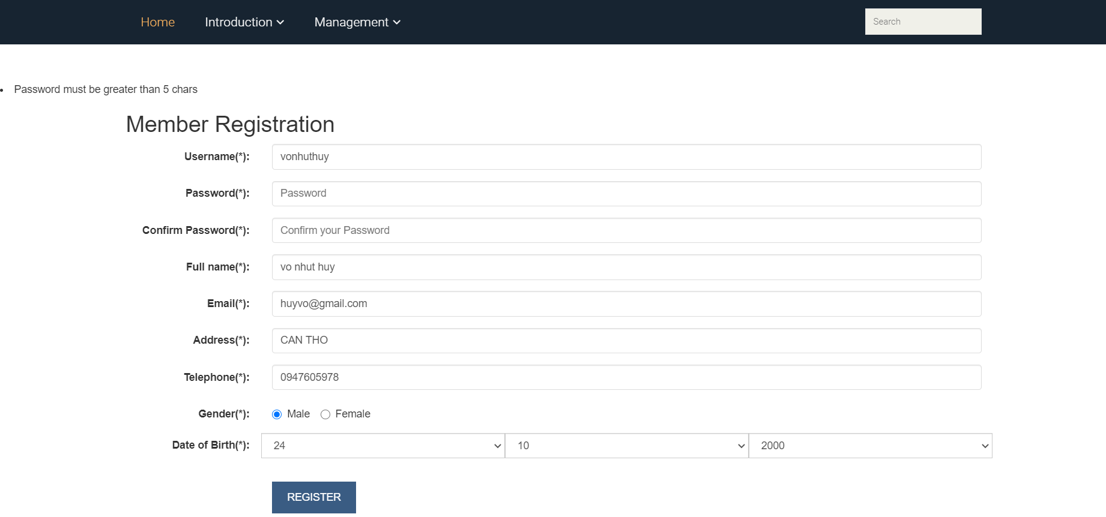

Figure 6: User enters information on member registration page

* After the user validly entered all the information of the Member register page, the website will display “You have registered successfully”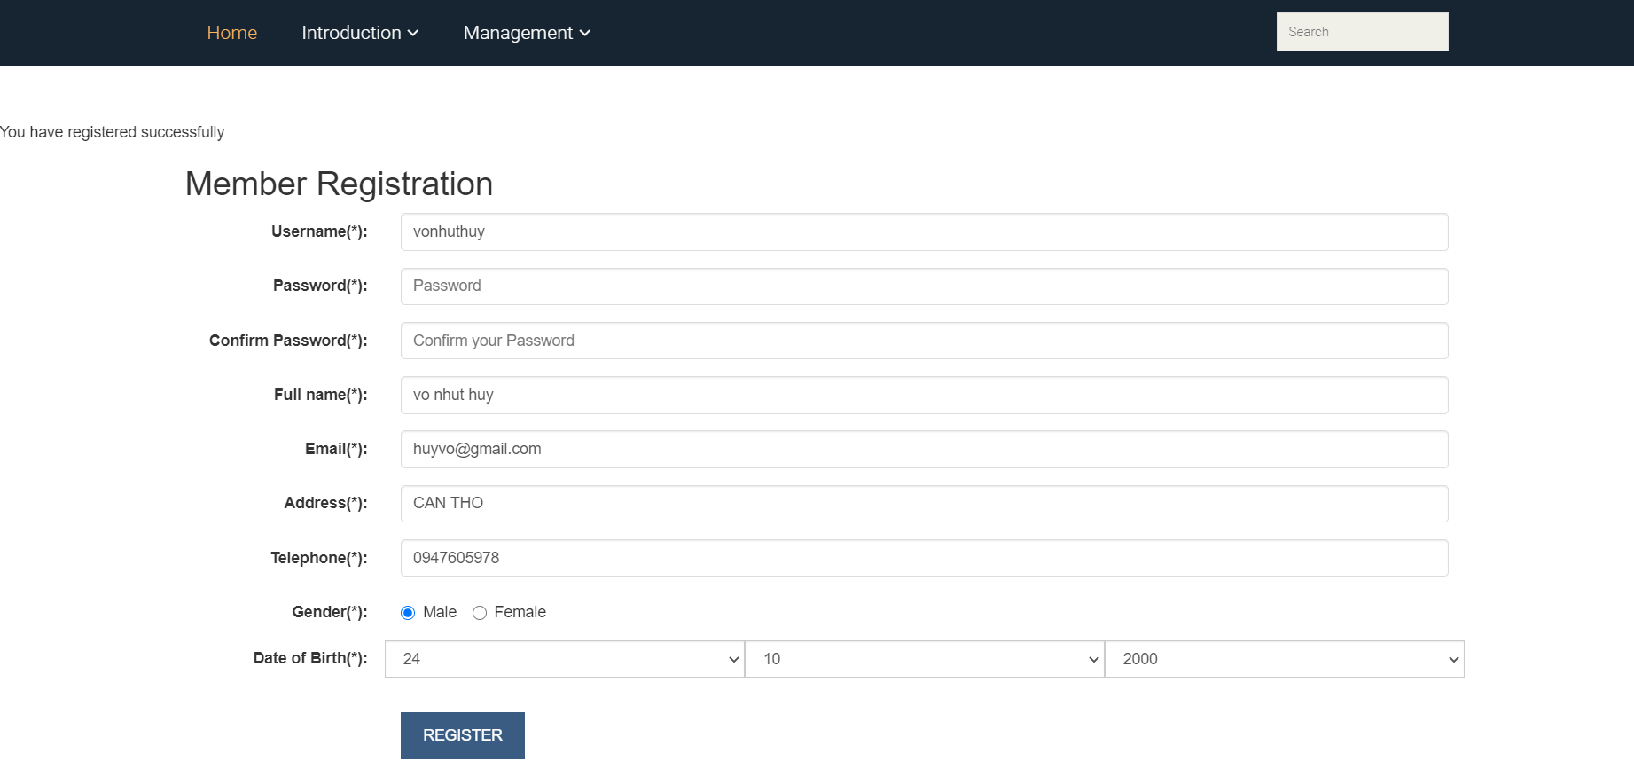

Figure 7: User successfully registered

1. Login to the registered account



Figure 8: Login button

* After the user clicks on the "Login" button, the website will pass the "Login" page for the user to login their account and password to the website.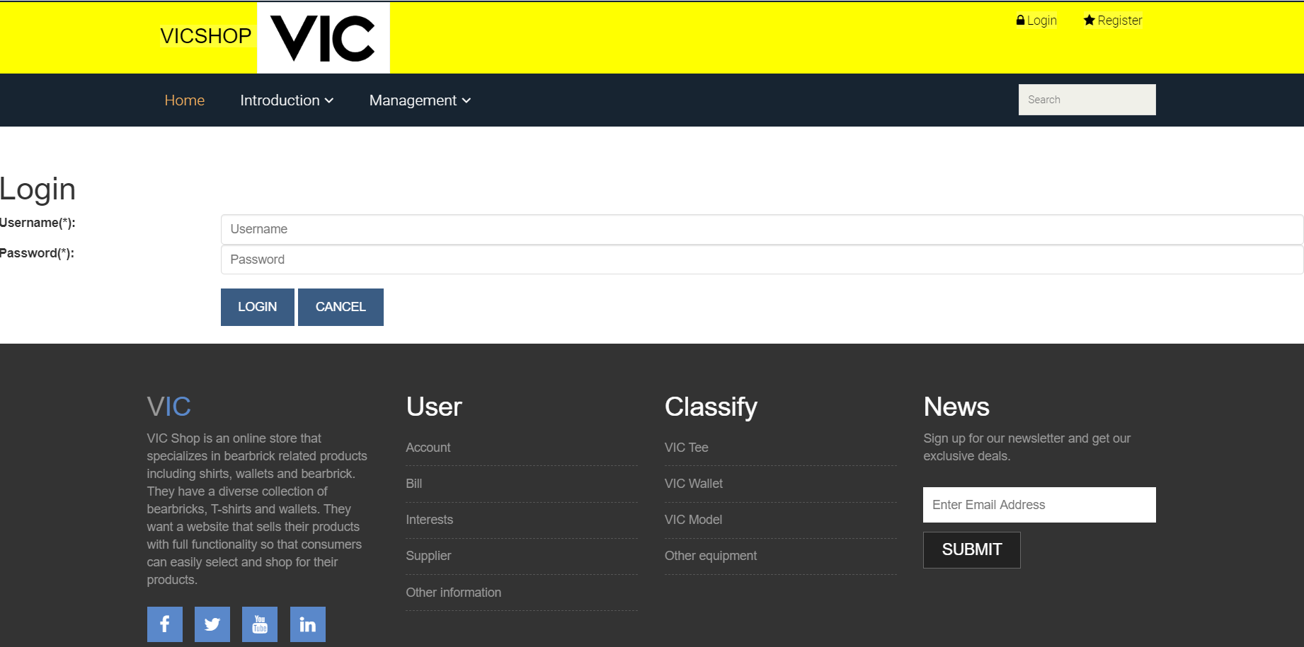

Figure 9: Login page

* The login page requires the user to enter the correct Username and Password information that he has registered.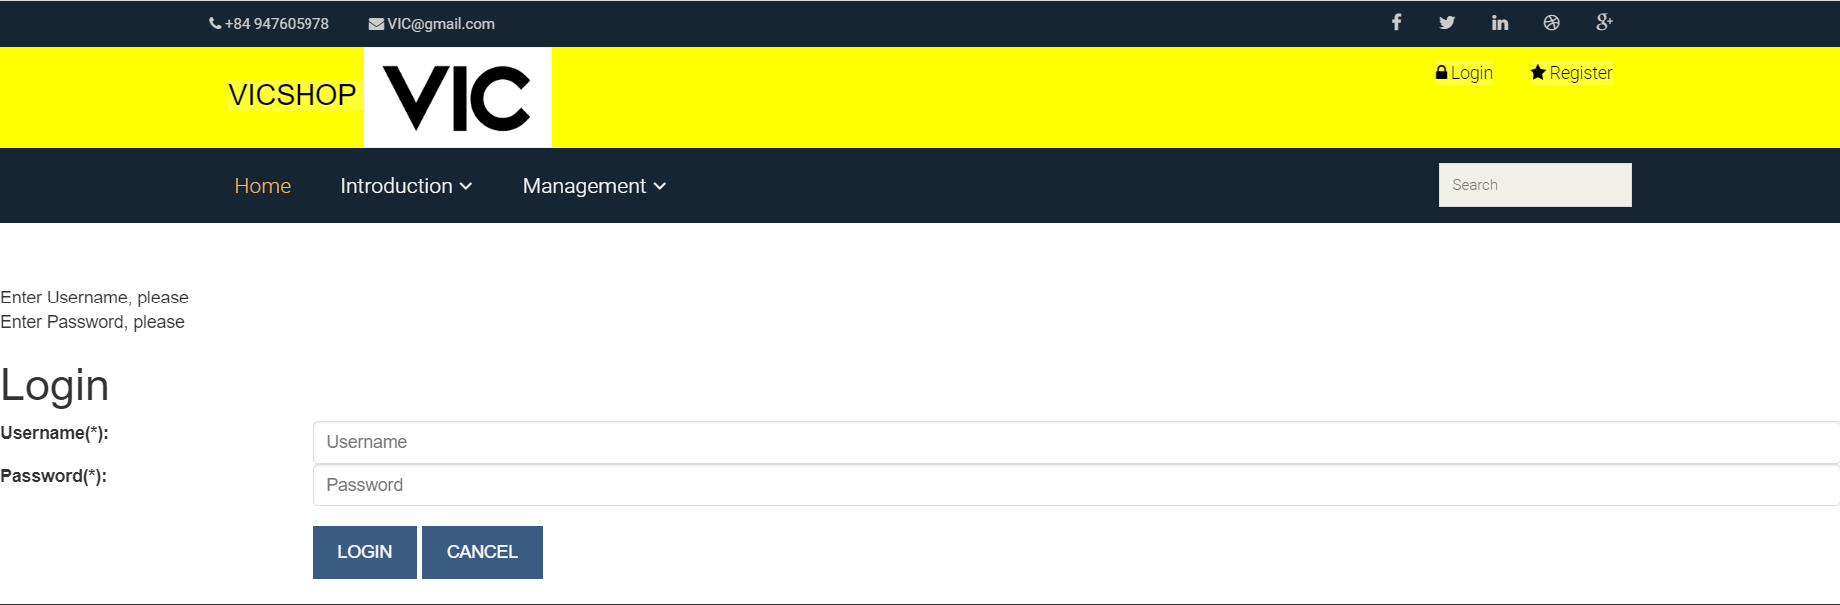

Figure 10: Login page's requirements

* If the user enters incorrect information for the Username or Password, the system will notify “Username or password doesn't exist. Please try again! ". The website requires the user to enter the correct Username and Password registered.

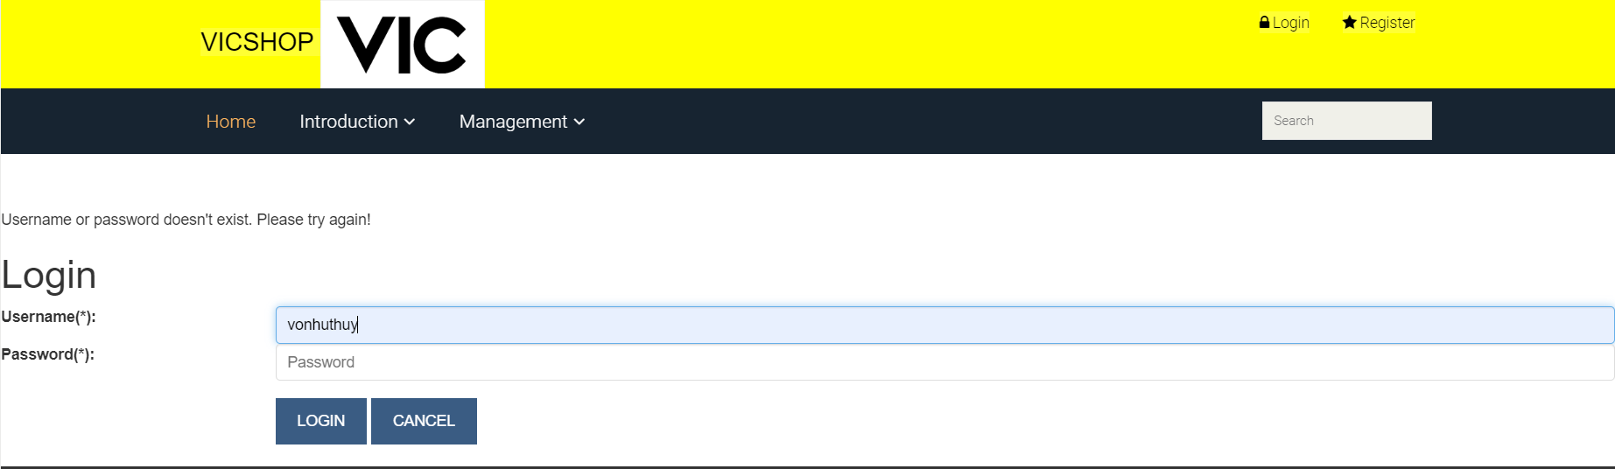

Figure 11: User entered incorrect username or password

* After the user enters the correct username and password the website will let you log in to the website. On the website will display "Welcome + username of the user"



Figure 12: The user has successfully entered

* After the user successfully login the user can view the products in the website.
* Including:
* There are two types of accounts that are registered: administrator account and client account. They are installed in the database with state = 0 for the client and state = 1 for the administrator.

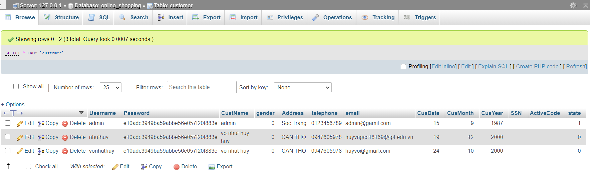

Figure 13: Database of the Customer table

* Login with the Customer account is to log in to an account with state = 0

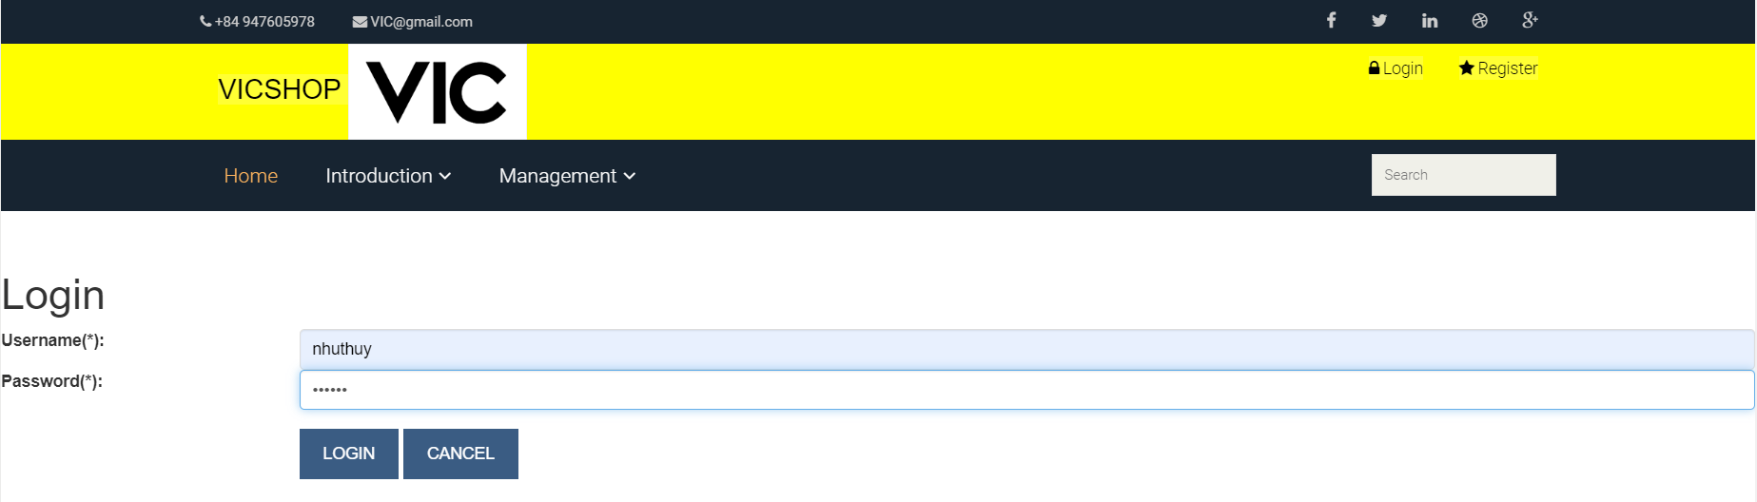

Figure 14: Login with the customer's account

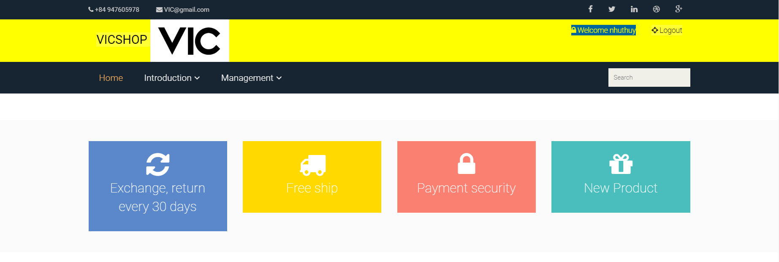

Figure 15: Customer has logged in successfully

* Login with the Admin account is to log in to an account with state = 1

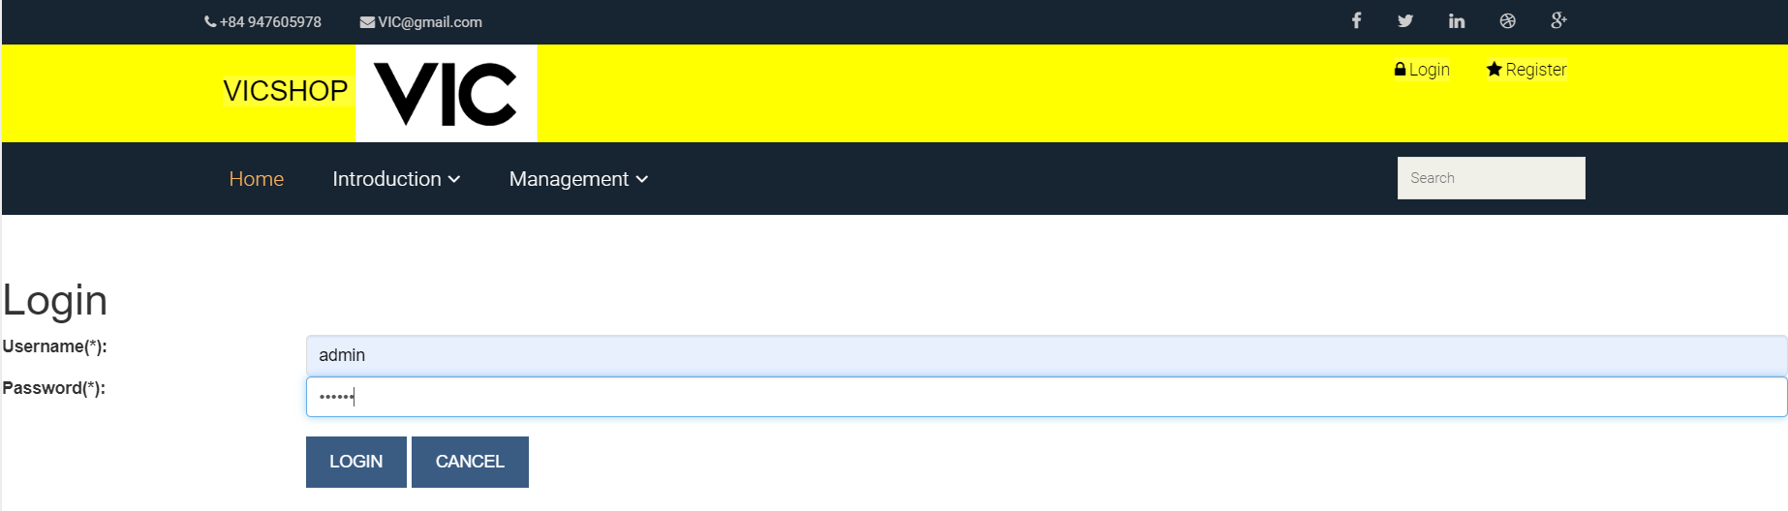

Figure 16: Login with the admin account

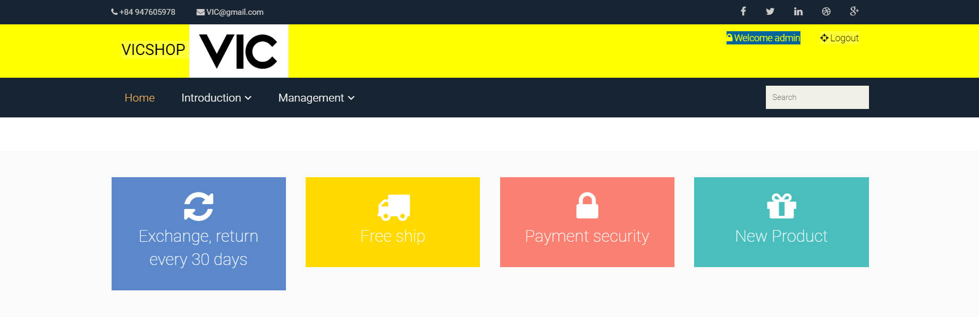

Figure 17: Login successfully with the admin account

* After logging in, the right corner of the screen will appear "Welcome + Username". You have successfully logged in.

1. Update Profile

* After the user wants to update personal information, the user will click on the "Welcome + username" button, the website will display the profile update form🡪 user can update Password, Full name, Address, Telephone.

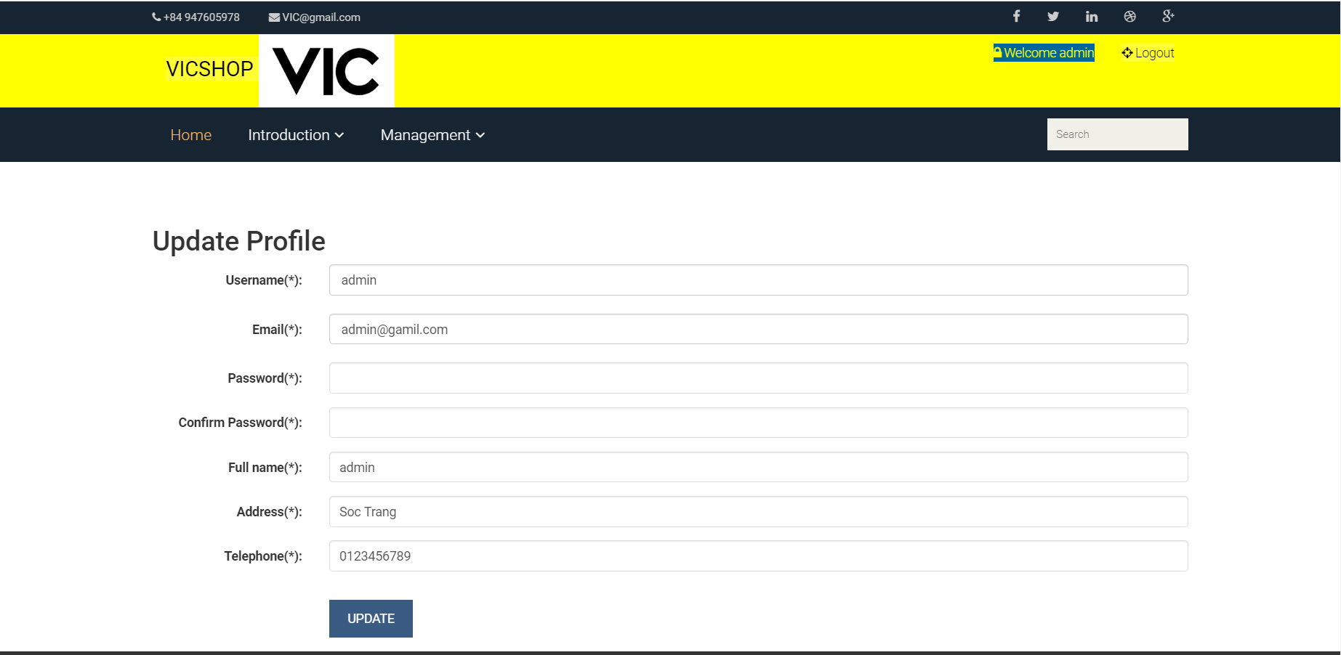

Figure 18: Form update profile

* Example:
* The name "admin" wants to update Full name, Address, Telephone, the user with the admin name will edit the information Full name, Address, Telephone with the information you want to update. Then press the button “UPDATE” the user information with the name “admin” will be updated.

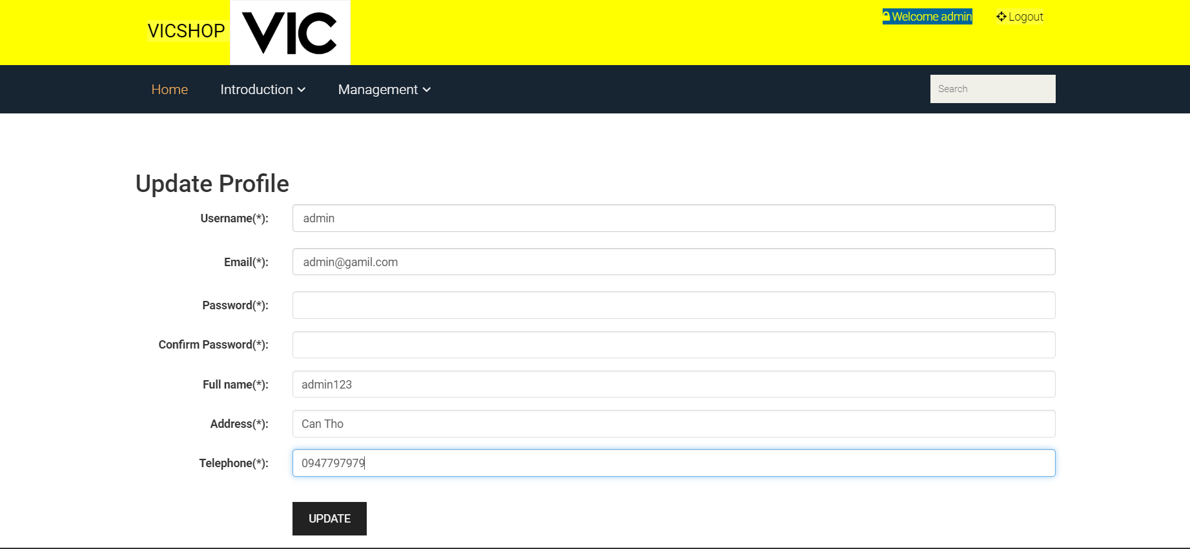

Figure 19: Update Profile users

* When the user updates his information on the web, the database also updates the user's information.
* 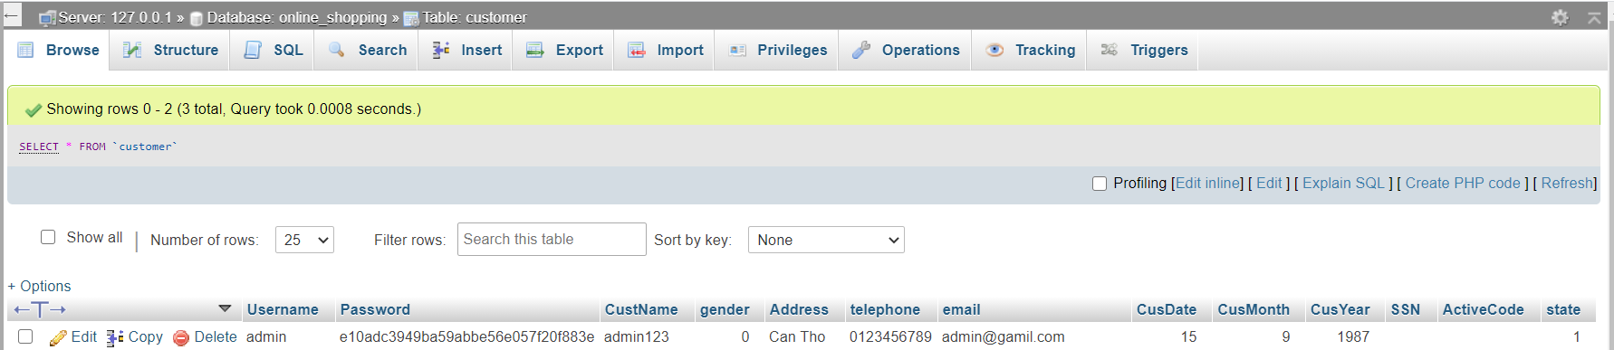

Figure 20: update profile in database

1. Product category management function

* When users click on the management interface, the interface will display "Category" and "Product".

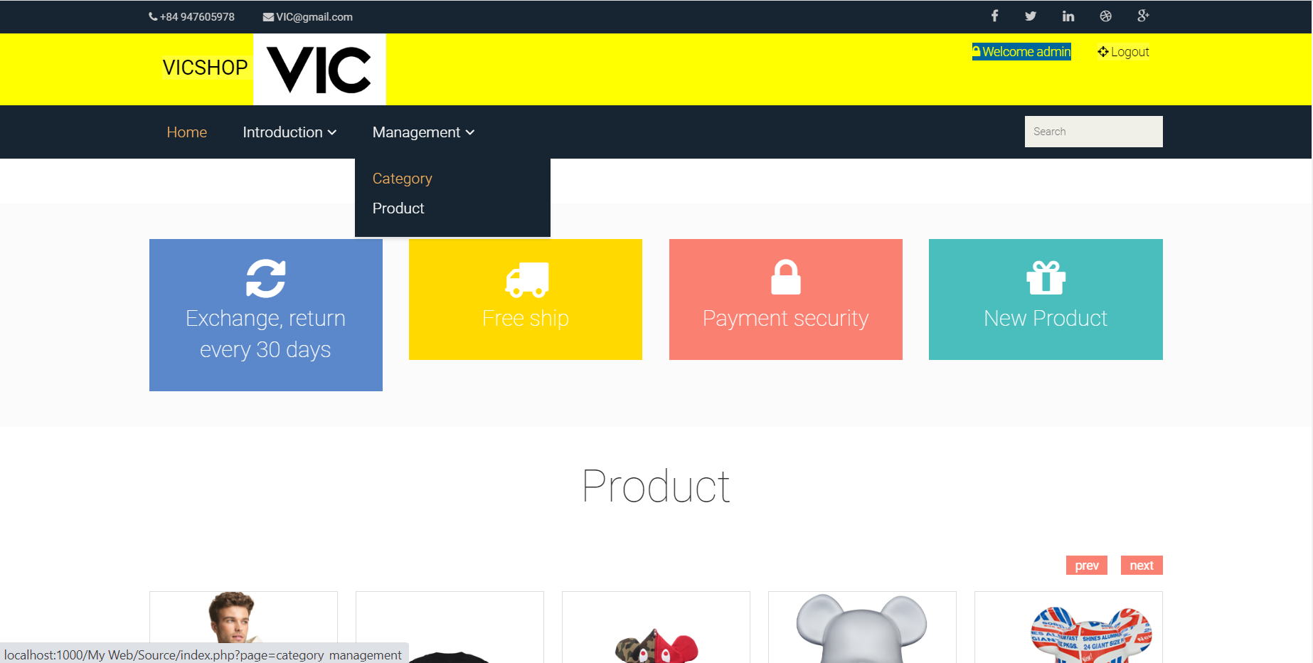

Figure 21: Category management function

* Next, clicking on the "Category" button will display the functional interface of "Category".

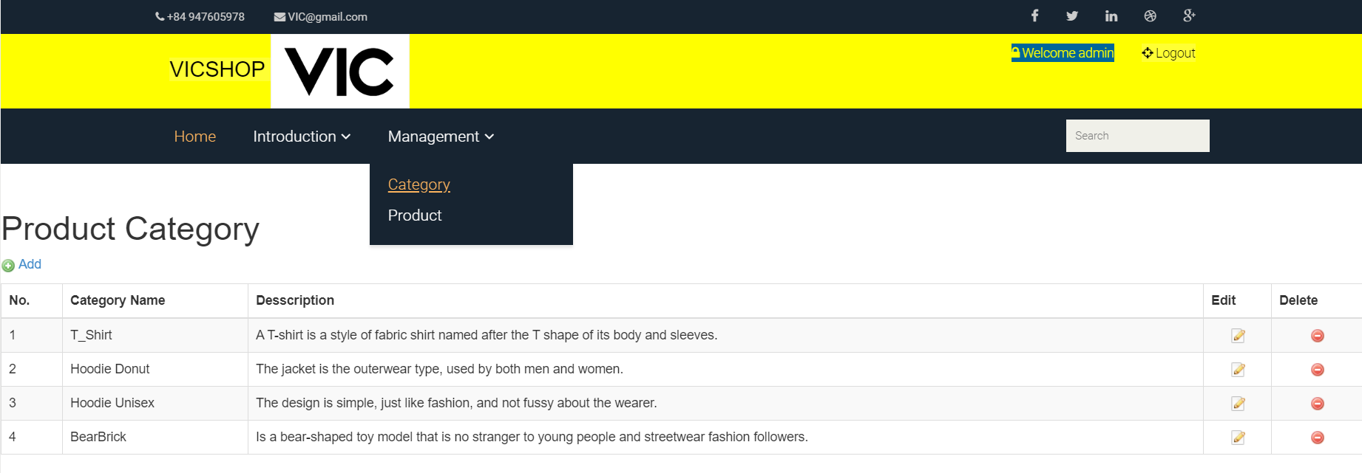

Figure 22: Interface Category management

* Function to add product categories
* When users click on the "Add" button, the website will display the interface of the add product categories.

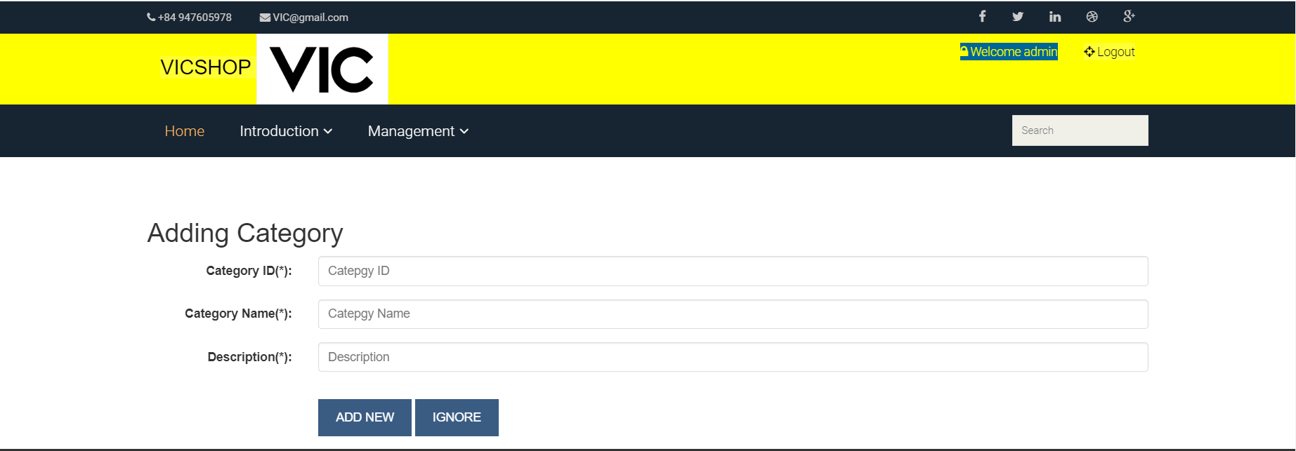

Figure 23: Interface add product categories

* Example: Admin add product categories
* Admin will fill in the information "Category ID, Category Name, Description".

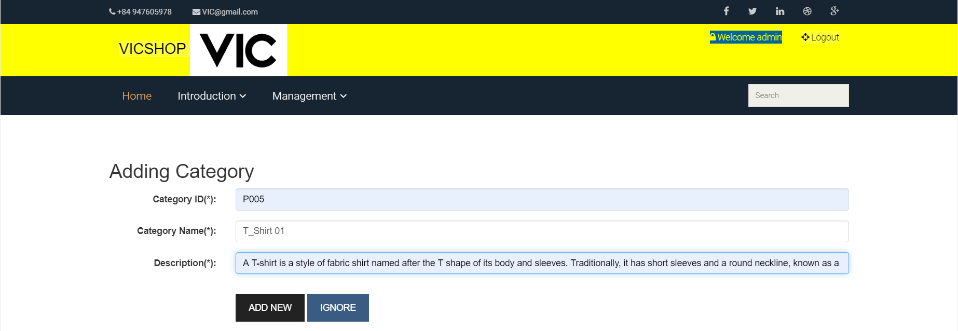

Figure 24: Admin add product categories

* After filling in the information of “Adding Category” Admin will click on “ADD NEW” button, all product information will be added.

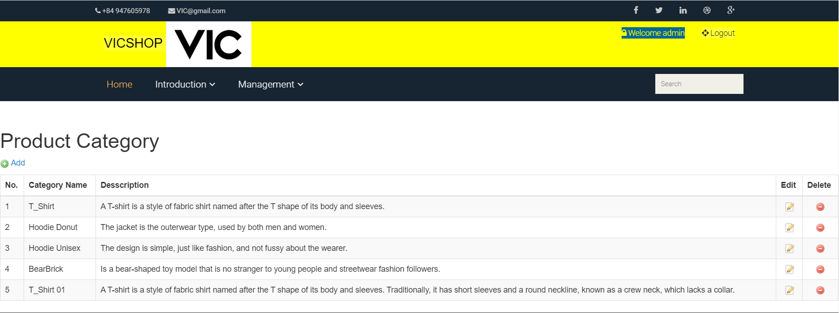

Figure 25: Add product categories successfully

* Function to update product categories

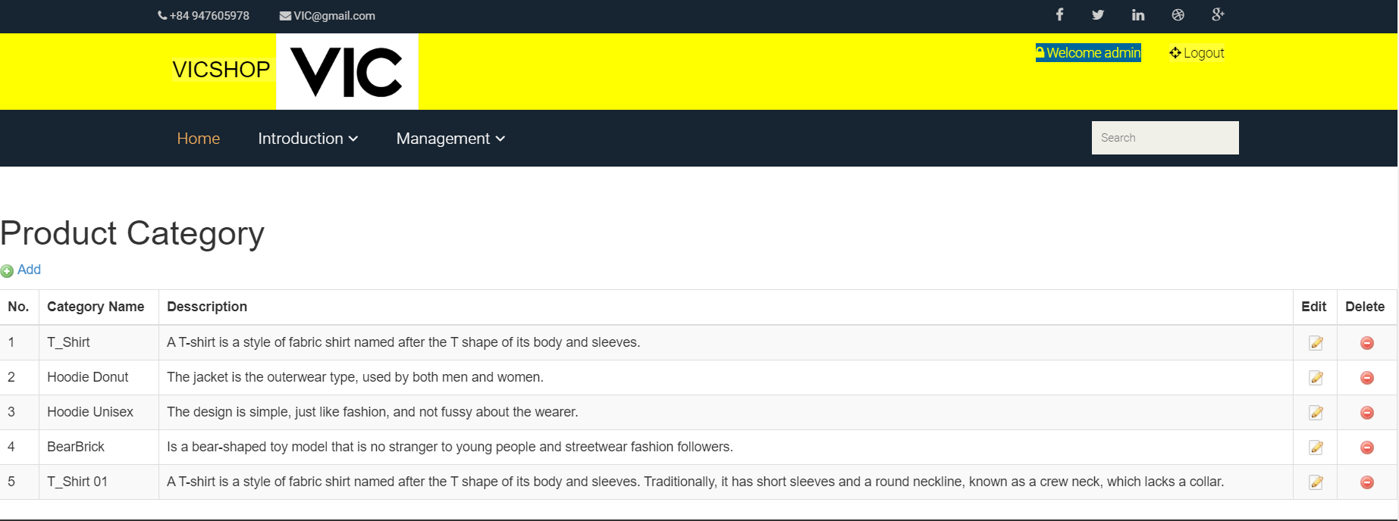

Figure 26: Update product category function

* When the user clicks on the "Edit" button to update the Product Category, in which the user can only update the Category Name, Description.

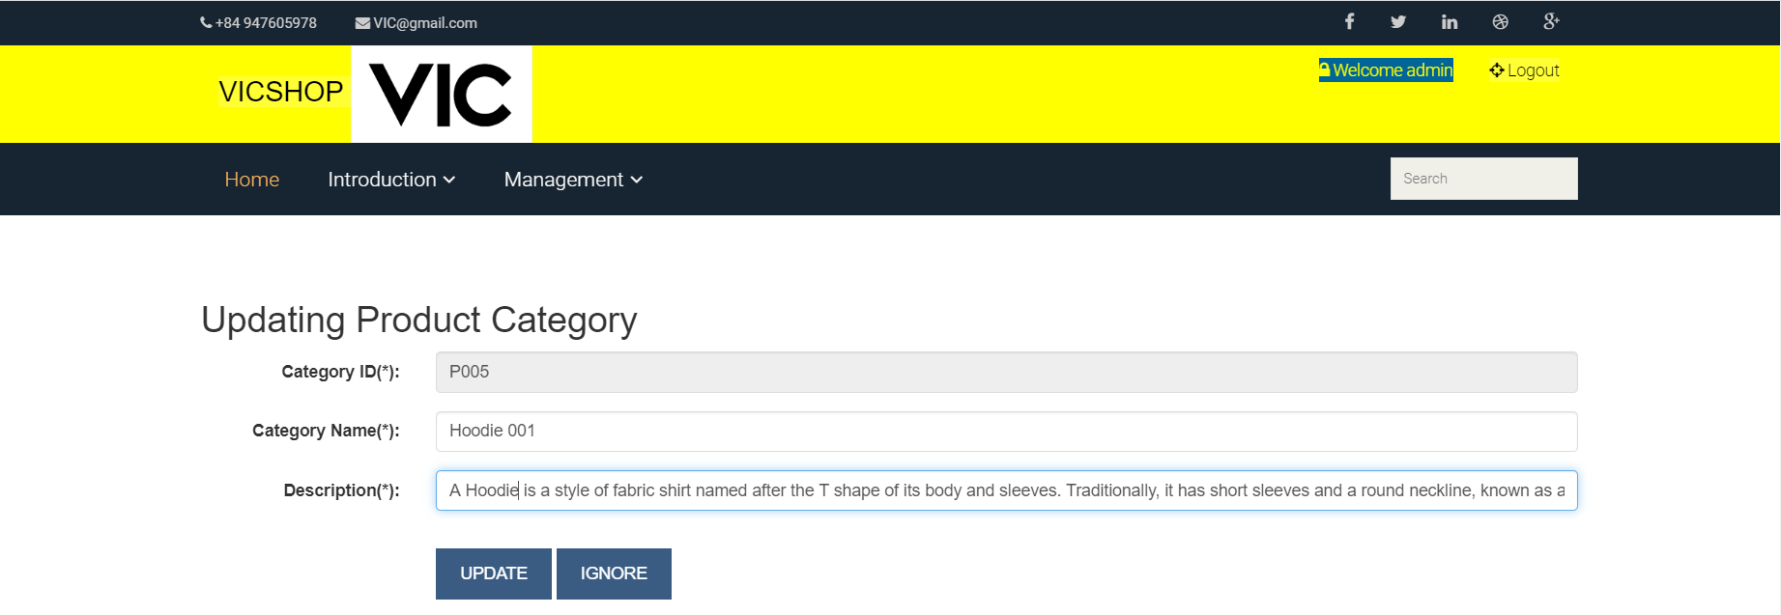

Figure 27: Form update product category

* After the user writes the content to be updated, then click on the button “UPDATE”, all the content to be updated by the user will be saved to the database and displayed on the website.

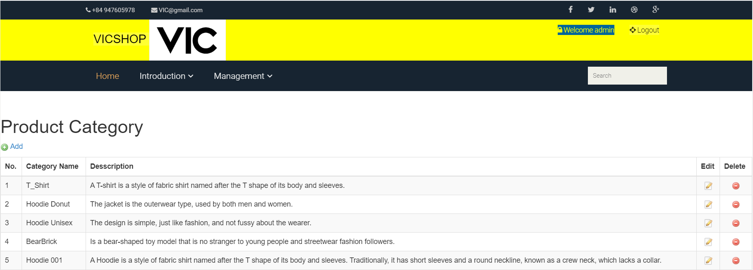

Figure 28: Update product category successfully

* Function to delete product categories

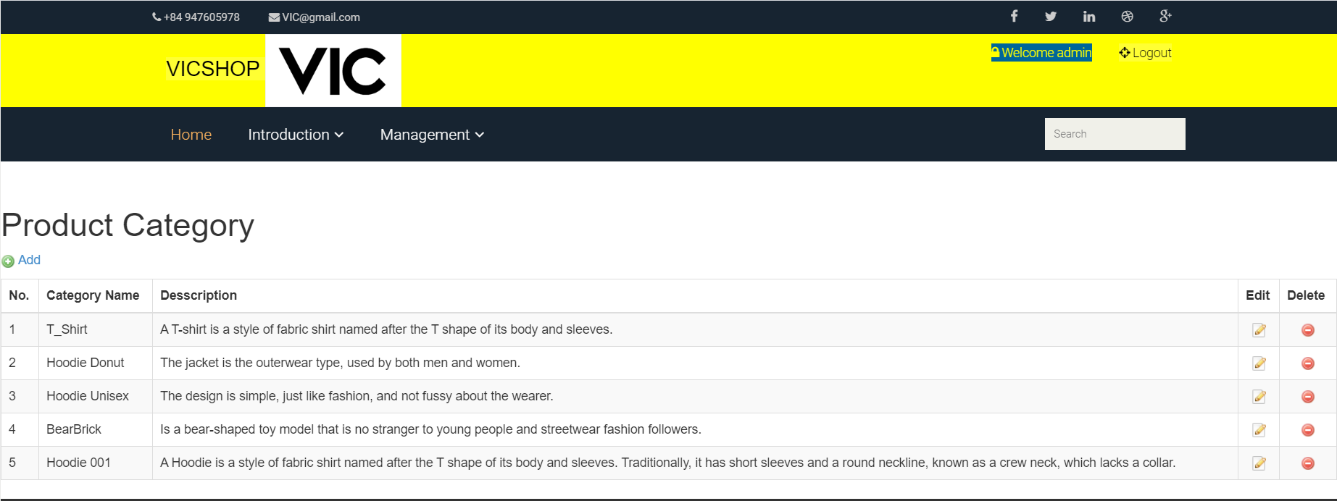

Figure 29: Delete product category function

* When users delete a product Category, they need to click on the "Delete" button in the Category Name to delete.

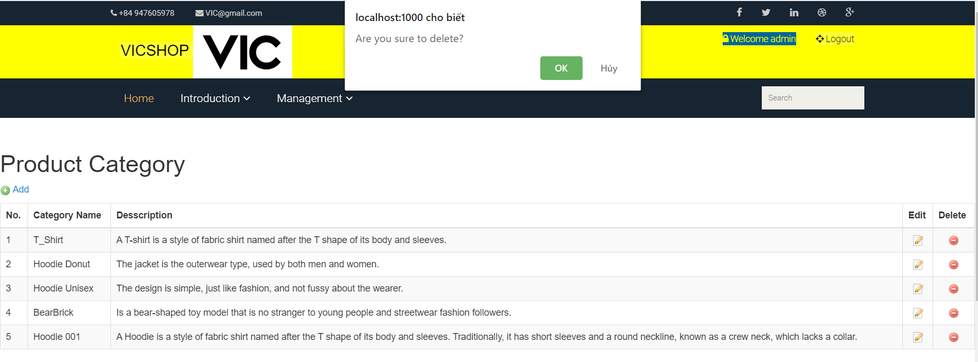

Figure 30: Notice when pressing delete button

* Then users want to continue to delete click "OK" button.

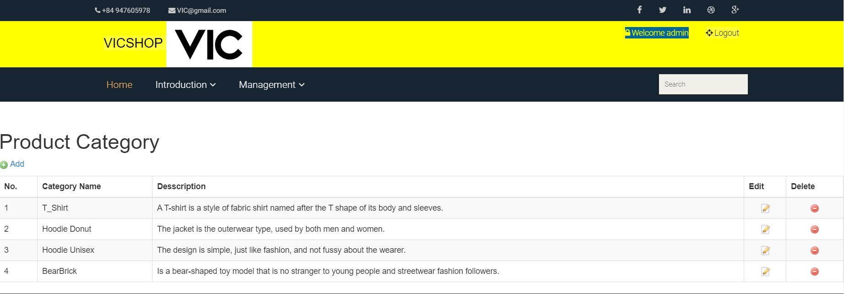

Figure 31: Xóa thành công sản phẩm No.5

* Product Management function

🡪 This is a function that only the login admin account can use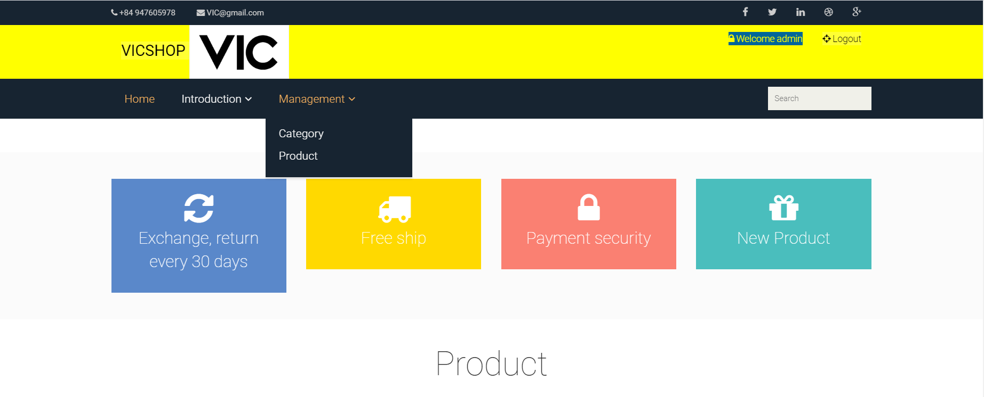

Figure 32: Product management function

* When the user clicks on “Product” the website will display the Product management page.

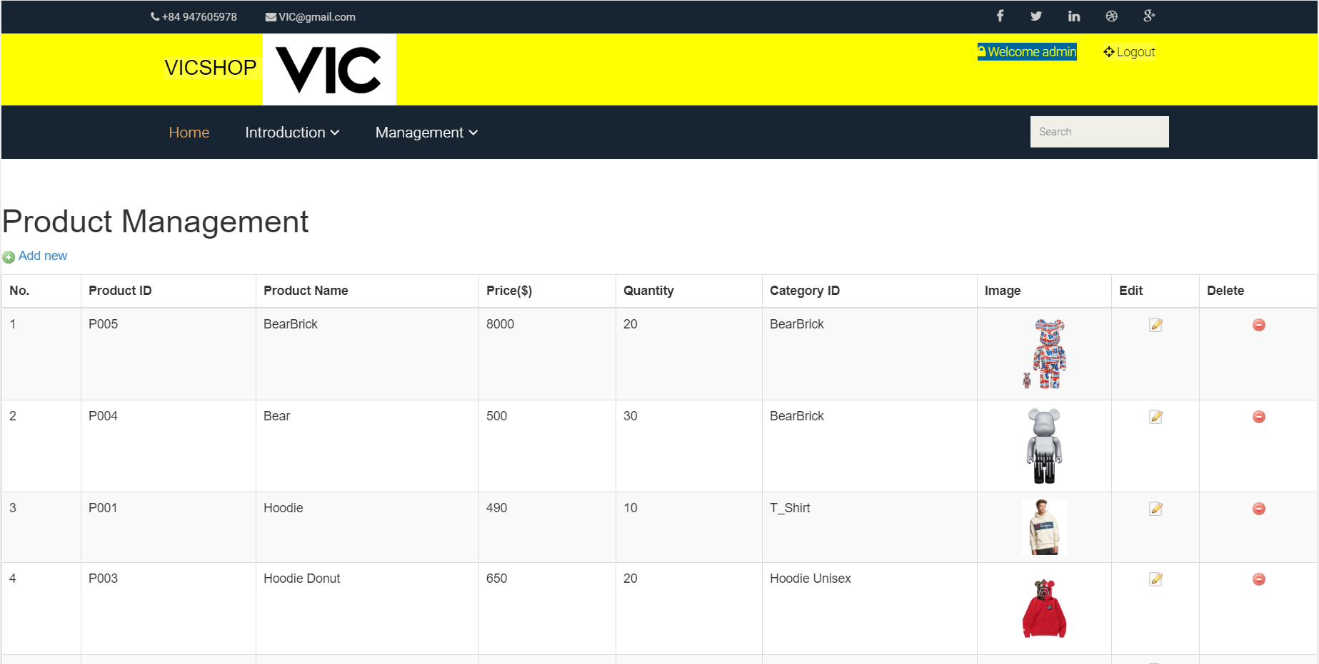

Figure 33: Product management interface

* Add product function

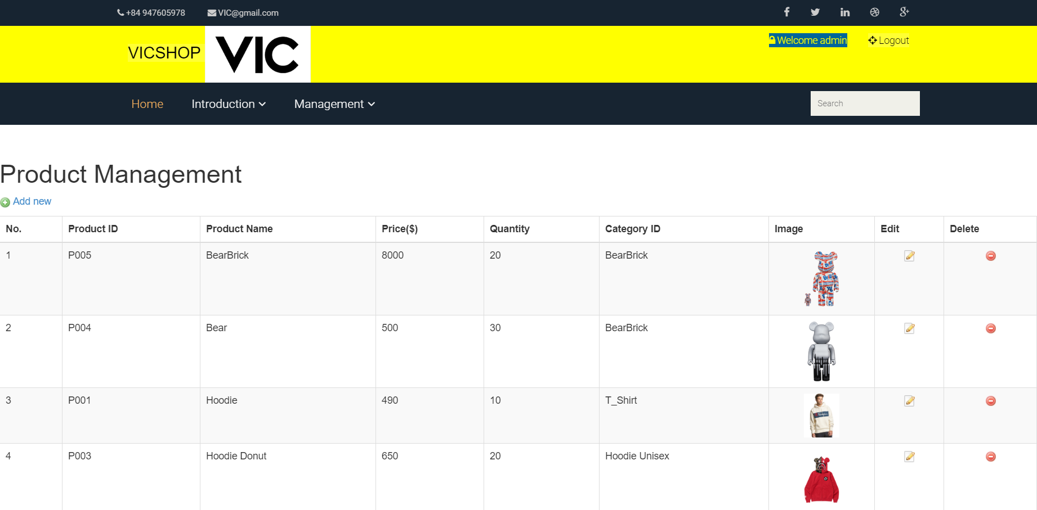

Figure 34: Add product function

* When the user adds the product, need to click the button "Add New", the website will go to the page for the user to enter full product information.
* Including: Product ID, Product name, Product category, Price, Short description, Detail description, Quantity, Image.

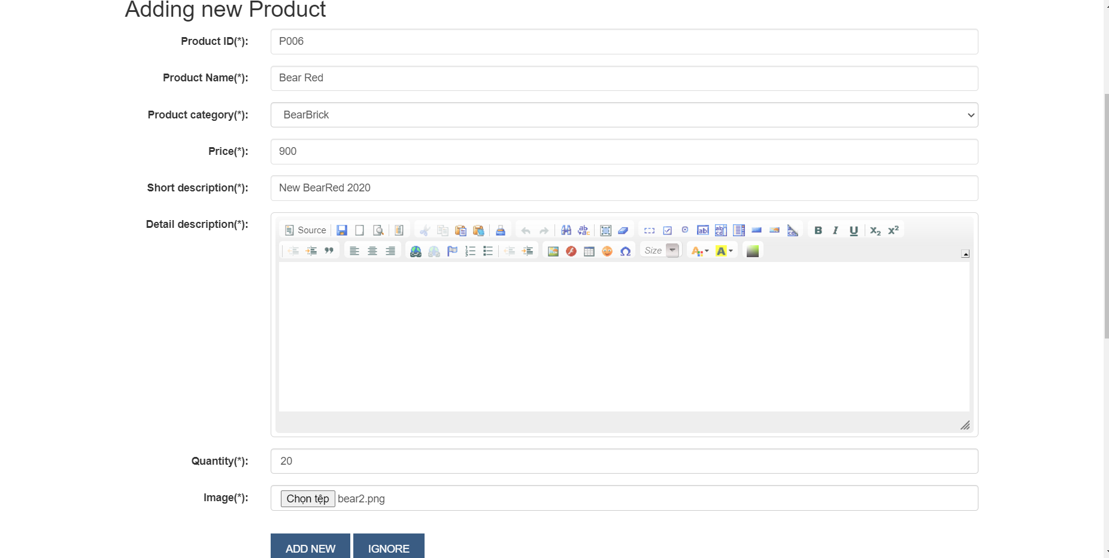

Figure 35: Form add new product

* User enter all valid add product information, then click “ADD NEW” button to save all information to database and display on website.

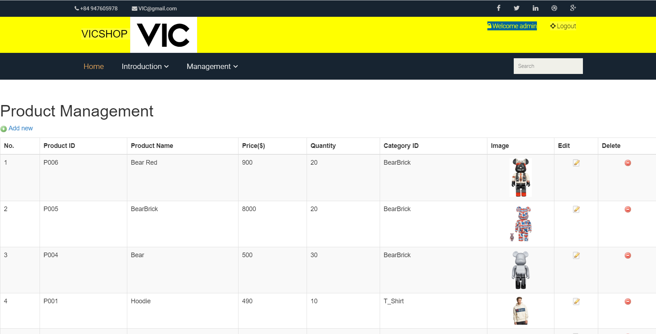

Figure 36: Add Product succsessfully

* Update product function

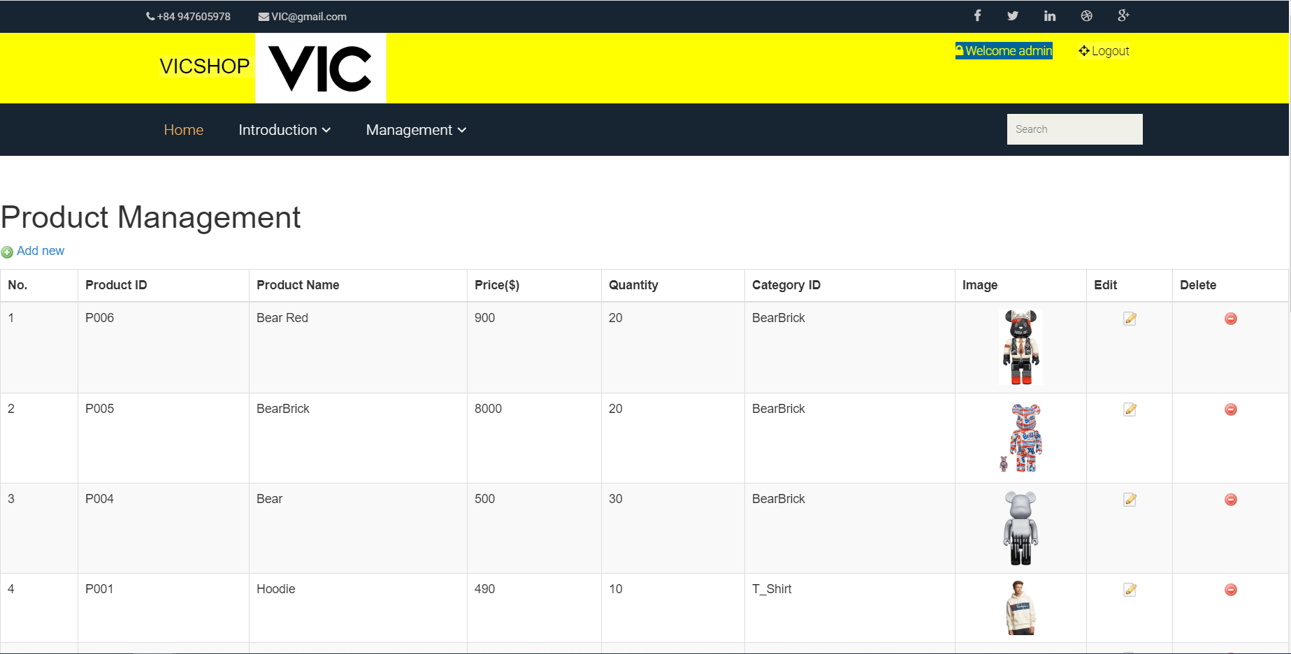

Figure 37: Update product button

* When users need to click on the "Edit" button when users update the product, the website will display the Product Update page for users to update product information.

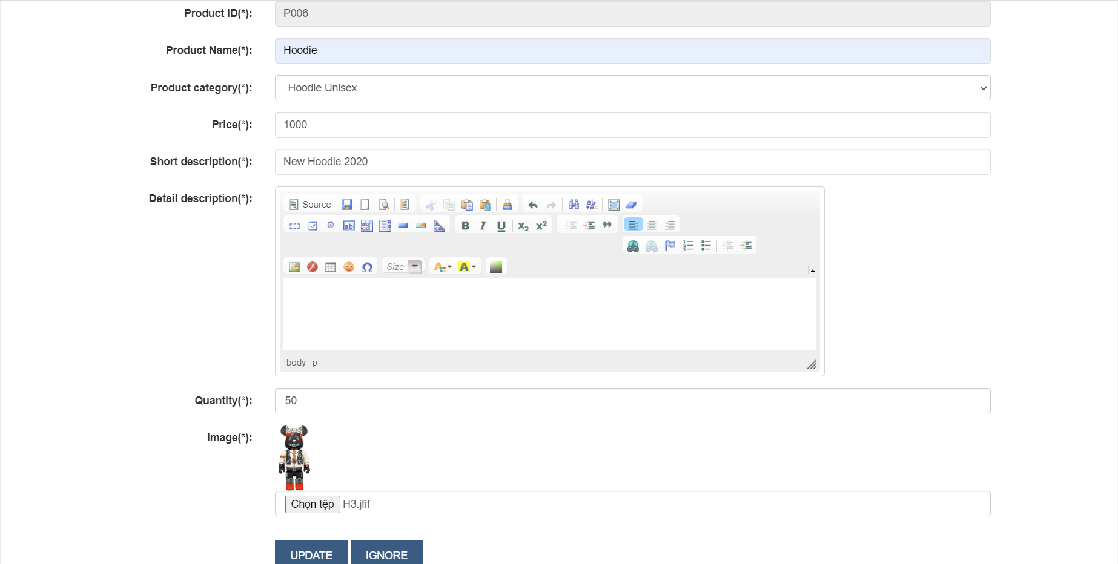

Figure 38: Fill in product updates

* After the user validates all the updated information, then click on the button “UPDATE” so that all the Update product information will be saved in the database and the information is displayed on the website.

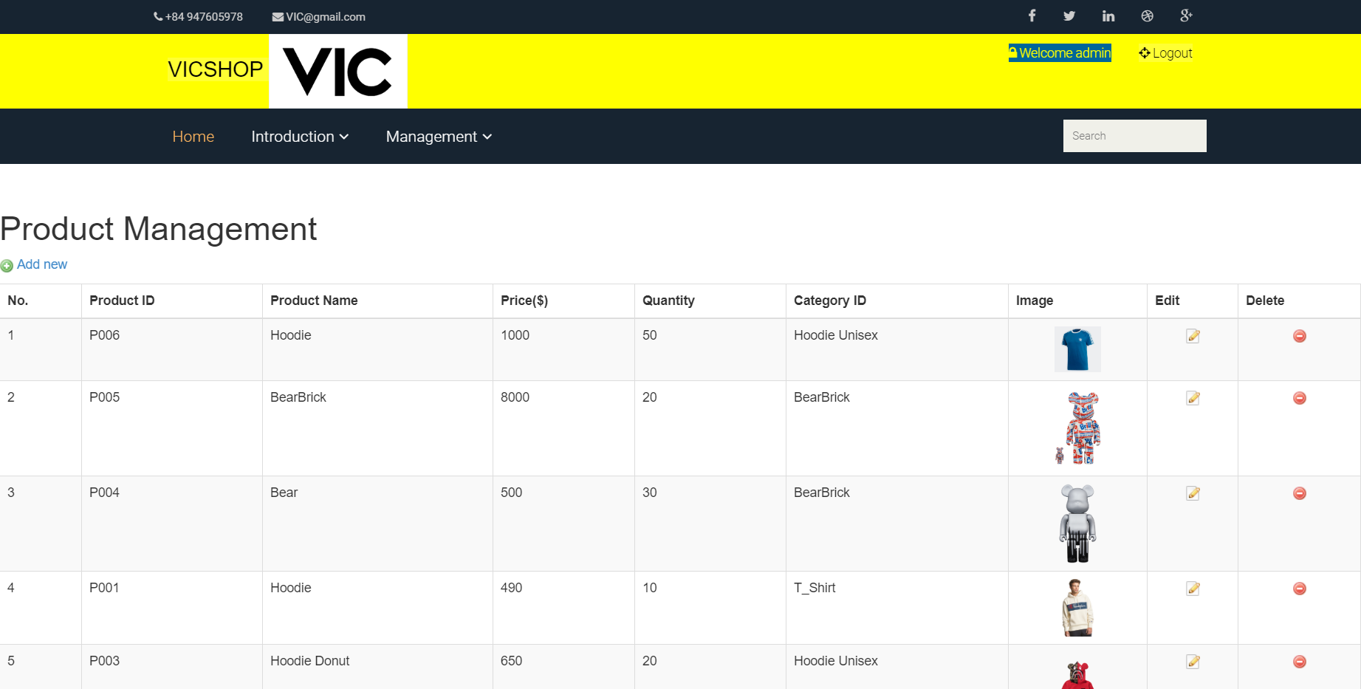

Figure 39: Update product P006 susscessfully

* Delete product function

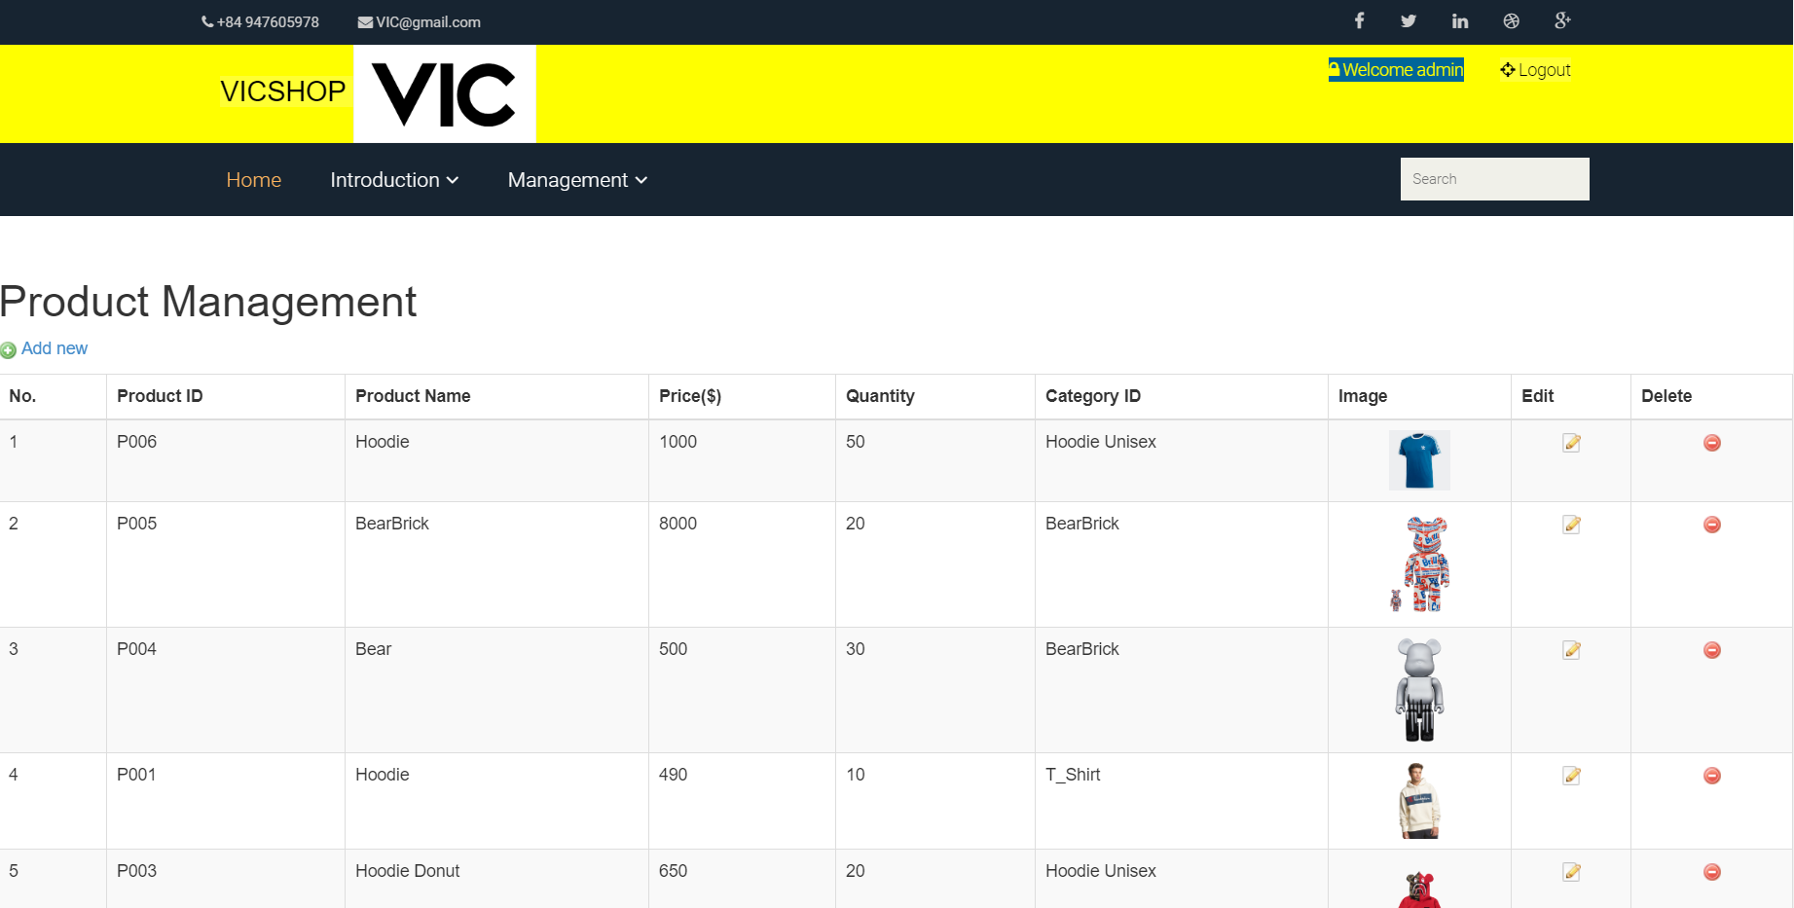Figure 40: Delete product function

* When users delete the product, they need to press the button below the Delete frame.

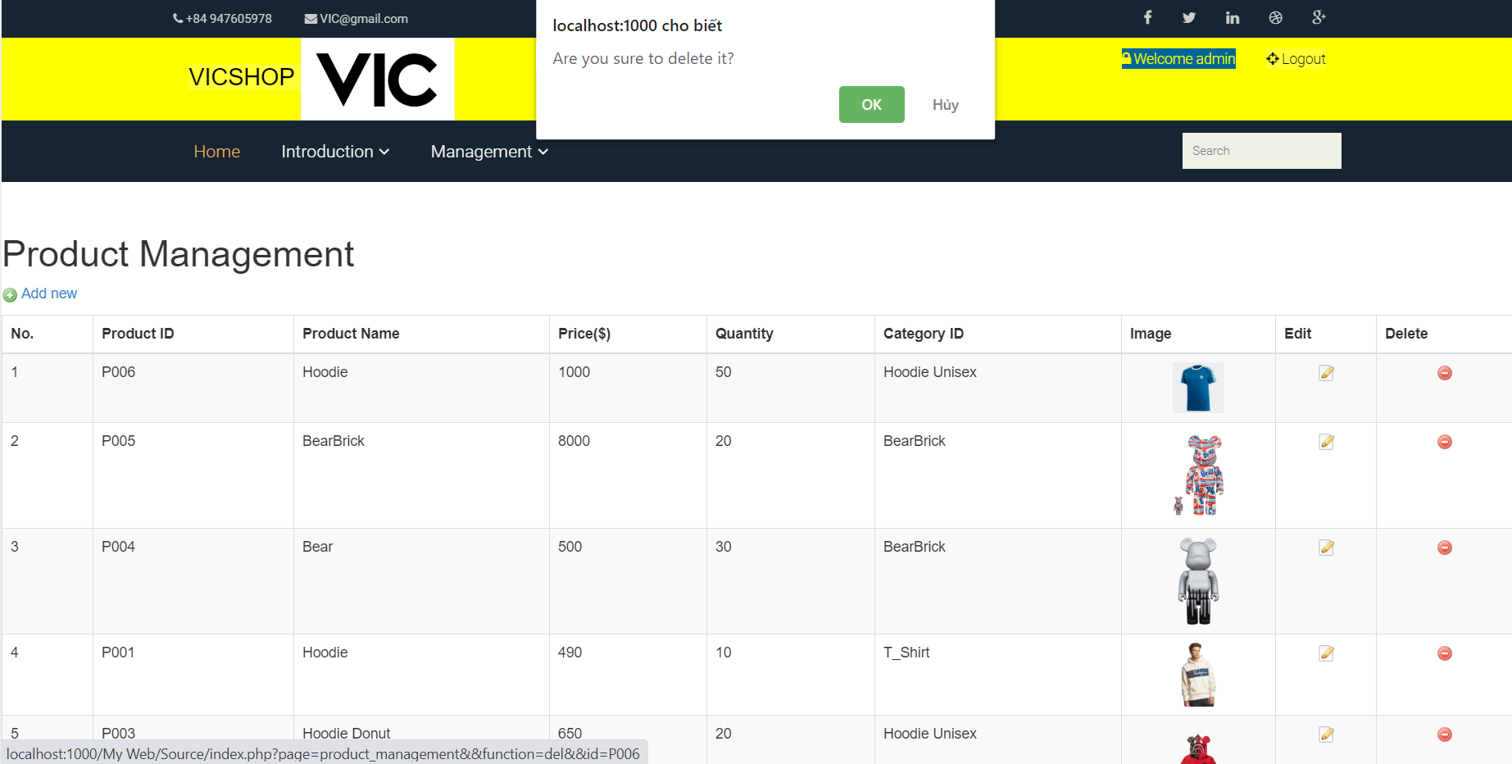

Figure 41: Interface after pressing the button below Delete

* If the user wants to delete, click “OK”, all product information that the user wants to delete will be deleted in the database and deleted on the Product Management page.

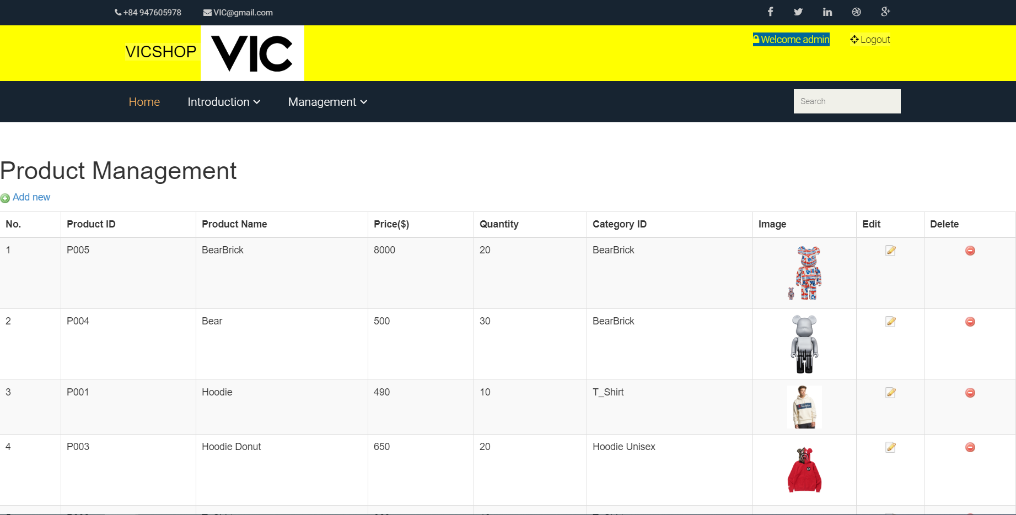

Figure 42: Delete product suscessfully

1. Log out function

* When the user no longer viewing the product can Log out his account, click the button "Logout".

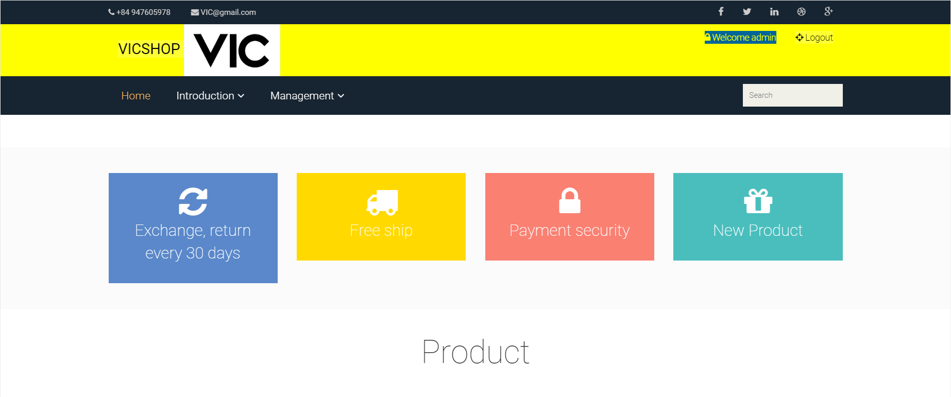

Figure 43: Log out function

* After the user presses the "Log out" button, the website will have a "Log in" button for another account to log in.

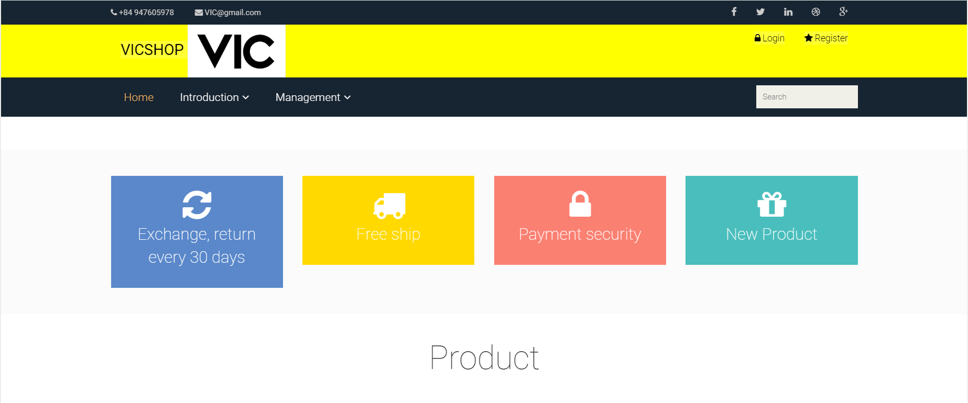

Figure 44: log out suscessfully

Sourch code: [https://drive.google.com/drive/folders/1GxRDpRb2qkSo06oJiQUL15HT32C6VetE?usp=sharing](https://drive.google.com/drive/folders/1GxRDpRb2qkSo06oJiQUL15HT32C6VetE?usp=sharing&fbclid=IwAR2xmFb1Q8x-458Z-YsigfOu81ICLHA27hUr2gfBL9qGpN8FB5cHz7anBg0)

* Admin:
* Account Admin: admin
* Password Admin: 123456
* Customer:
* Account Customer: nhuthuy
* Password Customer: 123456

# P7. Create a suitable test plan identifying key performance areas and use it to review the functionality and performance of your website. User Experience (UX) and User Interface (UI).

|  |  |  |  |  |  |  |
| --- | --- | --- | --- | --- | --- | --- |
| No. | Test Case | Function | Input data | Expected output | Actual output | Evaluation |
| 1. | Verify that the registration of personal information is successful | Register | Username: “vonhuthuy78”  Password: “123456”  Confirm Password: “123456”  Full name: “ vo nhut huy”  Email: “[nhuthuyvo@gmail.com](mailto:nhuthuyvo@gmail.com)”  Address: “ Vinh Long”  Telephone: “0979078128”  Gender: “Male”  Date of Birth: “24-10-2000” | "You have registered successfully" message is displayed | "You have registered successfully" message is displayed | Pass |
| 2. | Verify that the registration of personal information is unsuccessful | Register | Username: “vonhuthuy78”  Password: “12345678”  Confirm Password: “12345678”  Full name: “ nhut huy”  Email: “[nhuthuyvo@gmail.com](mailto:nhuthuyvo@gmail.com)”  Address: “ Can Tho”  Telephone: “0979078128”  Gender: “Male”  Date of Birth: “28-10-2001” | "Username or email already exists! Please enter another name (email)!" message is displayed | "Username or email already exists! Please enter another name (email)!" message is displayed | Pass |
| 3. | Verify that Home page and “Hi,…” are displayed when user enters valid username and password | Log in | Username: admin  Password: 123456 | Home page and “Wellcome, admin” are displayed | Home page and “Wellcome, admin” are displayed | Pass |
| 4. | Verify that “Username or password doesn't exist. Please try again!” massage is displayed when user enters invalid username or password | Log in | Username: admin  Password: 123456789 | “Username or password doesn't exist. Please try again!” message is displayed | “Username or password doesn't exist. Please try again!” message is displayed | Pass |
| 5. | Verify that the product information generated in the Category management page was successful. | Add Category | Category ID: “P005”  Category Name:  “T-Shirt 01”  Description:  “A T-Shirt is a type of fabric shirt name after the T-Shape its body and sleeves.” | “Add Product category successfully” message is displayed | “Add Product category successfully” message is displayed | Fail |
| 6. | Verify that the product info created in the Category Manager page failed | Add Category | Category ID: “P004”  Category Name:  “T-Shirt 01”  Description:  “A T-Shirt is a type of fabric shirt name after the T-Shape its body and sleeves.” | “Duplicate category ID or Name” message is displayed | “Duplicate category ID or Name” message is displayed | Pass |
| 7. | Verify that the Category product information is updated on the successful Category management page. | Update Category | Category Name:  “T-Shirt001”  Description:  “A T-shirt is a style of fabric shirt named after the T shape of its body and sleeves.”  in Category ID: P005 | “Update Product category successfully” message is displayed  page | “Update Product category successfully” message is displayed  page | Fail |
| 8. | Verify that the Category product information is updated on the unsuccessful Category management page. | Update Category | Category Name:  “T-Shirt01”  Description:  “A T-shirt is a style of fabric shirt named after the T shape of its body and sleeves.”  in Category ID: P005 | “Duplicate category Name” message is displayed  page | “Duplicate category Name” message is displayed  page | Pass |
| 9. | Verify that the Category product information is deleted on the successful Category management page. | Delete Category | Click “Delete” button | Show the confirm dialog “Are you sure to delete”. | Show the confirm dialog “Are you sure to delete”. | Pass |
| 10. | Verify that the product information generated in the Product management page was successful. | Add product | ProductID: “P006”  Product Name: “Hoodie Donut New”  Product category:  “ Hoodie Unisex”  Price: “600”  Short description: “New product”  Detail description: “New product”  Quantity: “20”  Image: "bear3.png" | “Add Product successfully” message is displayed | “Add Product successfully” message is displayed | Fail |
| 11. | Verify that the product information created on the Product Management page failed. | Add product | ProductID: “P002”  Product Name: “T_Shirt”  Product category:  “T_Shirt 01”  Price: “600”  Short description: “New product”  Detail description: “New product”  Quantity: “20”  Image: "bear2.png" | “Duplicate product ID or Name” message is displayed | “Duplicate product ID or Name” message is displayed | Pass |
| 12. | Verify that the product information is updated on the successful Product management page. | Update Product | Product Name: “BearBear New  Product category:  “BearBear”  Price: “9000”  Short description: “BearBlack”  Detail description: “BearBlack”  Quantity: “10”  Image: "mbear3.png"  In Product ID: “P005” | “Update Product successfully” message is displayed  page | “Update Product successfully” message is displayed  page | Pass |
| 13. | Verify that the product information is updated on the unsuccessful Product management page. | Update Product | Product Name: “T_Shirt”  Product category:  “T_Shirt01”  Price: “800”  Short description: “T-Shirt New”  Detail description: “T-Shirt New”  Quantity: “20”  Image: "bear9.png"  In Product ID: “P004” | “Duplicate product Name” message is displayed  page | “Duplicate product Name” message is displayed  page | Pass |
| 14. | Verify that the product information is deleted on the successful Product management page. | Delete product | Click “delete” button | Show the confirm dialog “Are you sure to delete”. | Show the confirm dialog "Are you sure to delete it?" | Pass |

REFERENCES

Robbins, J.N., 2012. *Learning web design: A beginner's guide to HTML, CSS, JavaScript, and web graphics*. " O'Reilly Media, Inc.".

Nixon, R., 2014. *Learning PHP, MySQL & JavaScript: With jQuery, CSS & HTML5*. " O'Reilly Media, Inc.".